Year 8: Chemical vs. Physical Changes

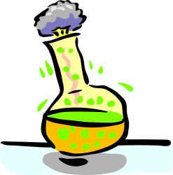

Name: _____________________________________

C:\Users\nathans\AppData\Local\Microsoft\Windows\Temporary Internet Files\Content.IE5\NK55P2C4\MC900434389[1].wmfHave you ever wondered . . .

1. Where sugar goes when it is dissolves in water?
2. Why you feel hot after exercise?
3. Why iron rusts but aluminium doesn’t?

**Pre-Quiz**

1. What are the three states of matter?
2. What is a *change of state* in science?
   1. Moving from WA to NSW.
   2. A solid, liquid or gas.
   3. A substance changing from a solid to a liquid.
   4. The atom hydrogen
3. What is contraction? ____________________________________________________
4. How come when your mum cooks a meal that the smell carries throughout the house? _______________________________________________________________

_____________________________________________________________________

1. C:\Users\nathans\AppData\Local\Microsoft\Windows\Temporary Internet Files\Content.IE5\XU5WH84K\MC900389488[1].wmfWhat is produced when a nail rusts?
   1. Oxygen and Carbon Dioxide
   2. Iron and water
   3. Brownification
   4. Iron Oxide
2. Why does ice float?
   1. It has less density than water.
   2. It gets so cold that it tries to stay closer to the warm sun.
   3. It’s so cold that it pushes the warmth away forcing it upwards.
3. What is a chemical reaction? __________________________________________________________________________________________________________________________________________________________________

**Physical Change:**

1. If _________________________________ has been formed during a change, then it must have been Physical Change.
2. Because no new substance has been formed, then the change is very likely to be _________________.

**Demonstration: (Bunsen burner, ice cube)**

The 3 Main States of Matter:

1. _____________
2. _____________
3. _____________

*Question 1: Think of three thing that belong to each state and add it to the mind map.*

**Twig Video: Solids, Liquids and Gasses**

*Question 2: Draw what water (H2O) would look like in each state, below label what* ***we*** *call them.*

|  |  |  |
| --- | --- | --- |
| Solid | Liquid | Gas |
| http://autosamplervials.kinesis.co.uk/wp-content/uploads/11090356.jpg | http://autosamplervials.kinesis.co.uk/wp-content/uploads/11090356.jpg | http://autosamplervials.kinesis.co.uk/wp-content/uploads/11090356.jpg |
| _______________ | ________________ | ______________ |

**Identifying Physical Change**

1. **Change of Shape or Form**
   1. A force is applied to ____________, bend, stretch, crush and twist objects.
   2. There is no _____________________formed.

Question: Draw an example using a tin can:

|  |  |
| --- | --- |
| Before | After |
|  |  |

1. **Expansion and Contraction**

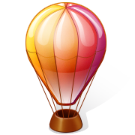

**Demonstration: (Thermometer, Bunsen burner, Water)**

* 1. Occurs when the temperature either i____________ or decreases.
  2. There is no new substance formed.
  3. Solids, liquids and gasses ___________ when they are heated up and take up more space.
  4. Solids, liquids and gasses __________ when they are cooled and take up less space.

*Questions: Use the table below to give an example of expansion and contraction of air (a gas) USING PARTICLES.*

* + - Which one will be higher from the ground? _______________________
    - Which balloon would have hotter air? _______________________

|  |  |
| --- | --- |
| **Hot air balloon with contracted air** | **Hot air balloon with expanded air.** |
|  |  |

1. **Changing Between States**

If a state of matter ________________ a lot in temperature it will change it’s state.

If a state of matter ________________ a lot in temperature it will change it’s state.

1. **C:\Users\nathans\AppData\Local\Microsoft\Windows\Temporary Internet Files\Content.IE5\QH2IKMBK\MC900437978[1].wmfMelting and Freezing**
   1. _______________ – Solid to a liquid
   2. Freezing/Solidification – ____________________________

Draw a picture using particles to show a liquid freezing and forming a solid.

|  |  |
| --- | --- |
| Liquid | Solid |
|  |  |

1. **Evaporation and Condensation**
2. Evaporation – _____________________________
3. _____________________ – Gas to a liquid

Draw a picture using particles to show a liquid evaporating from a hot kettle.

|  |  |
| --- | --- |
| Before Evaporation | During Evaporation |
|  |  |

1. **Sublimation and Deposition**
2. ______________________ – Solid to a gas
3. Deposition – __________________

**Demonstration: Dry ice**

**Twig Video: Changing States of Matter**

|  |  |
| --- | --- |
| **Short Quiz** | |
| 1. When a solid becomes a liquid we say it is . . .    1. Boiling    2. Melting    3. Condensing    4. Freezing | 1. If pure water is in contact with ice it’s temperature will be . . .    1. 0°C    2. 50°C    3. 100°C    4. 200°C |
| 1. The change from a gas to a liquid is called . . .    1. Boiling    2. Evaporation    3. Melting    4. Condensing | 1. When a liquid escapes near the surface, we call it . . .    1. Condensing    2. Boiling    3. Melting    4. Evaporating |

**Label the following arrows with the correct term that describes the change of state.**

**Mixing and Separating**

_________________ – When two states of matter are together but remain individual.

_________________ – When two states of matter are removed from being together.

**Demonstration:** M&M’s mixed in a bowl.

* 1. Dissolving is when a solid is mixed with a liquid forming a solution. The solid often disappears as it spreads evenly throughout the solution.
  2. A good example of this in everyday life is salt water. (remember our experiment in week 1)
  3. If we were to boil the water away, there would be salt left behind.
  4. 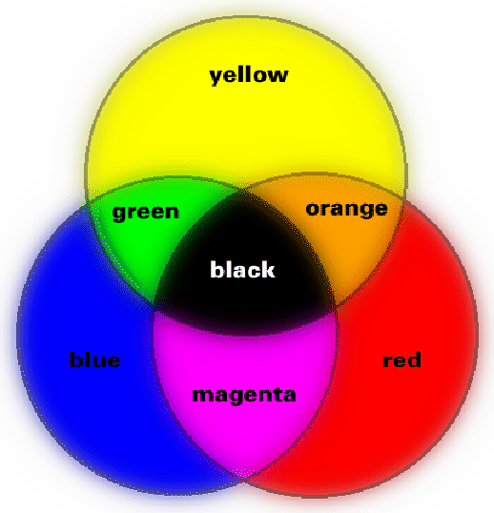It’s important to remember that the solute and solvent are not forming a new substance. They are just mixed together, just like the M&Ms.
     1. ____________ – is the solid.
     2. ____________ – is the liquid.

**Twig Video: Solutions**

**Questions:**

1. Observe the diagram showing the salt NaCl (Sodium Chloride) dissolving into the water.
   1. 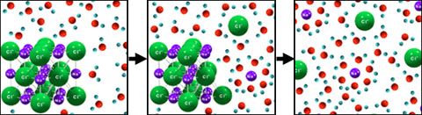Circle the solute in each of the pictures.
   2. Explain what is happening to the solute. ______________________________________________________________________________________________________________________________________________________
   3. If we were to boil the solution, which of the particles would be evaporated?

The water (H2O) or the salt (NaCl)

**Identifying Chemical Change**

Practical Activity: Observing Chemical Reactions

(Pearson pg. 212)

|  |  |  |
| --- | --- | --- |
| **Reaction Number** | **Reaction** | **Observation** |
| **1** | HCl + Blue Litmus |  |
| **2** | HCl + Magnesium |  |
| **3** | HCl + Silver Nitrate |  |
| **4** | HCl + Sodium Hydroxide |  |

1. If a new substance has been formed during a change, then it must have been Chemical Change.
2. Types of New Substances
   1. 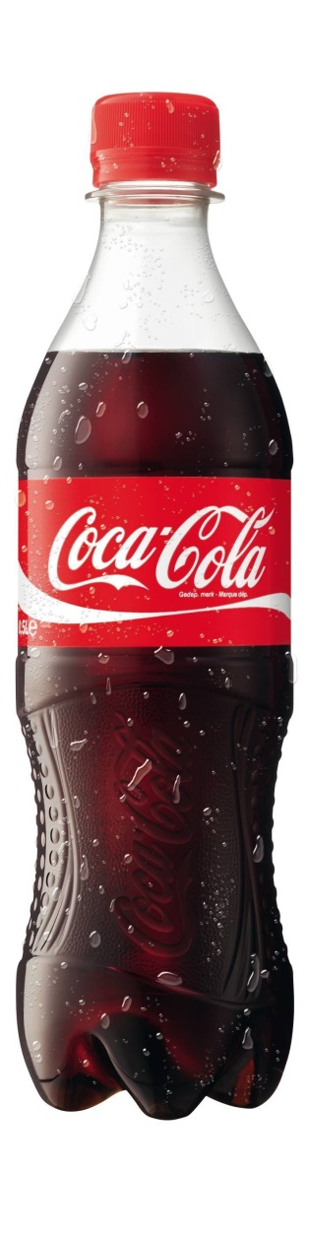A _______________ change in ____________

Example:

* + 1. Burning a match or toast.
    2. Metal _____________.
  1. Smelling gas/Seeing _____________

Example:

* + 1. Rotten Eggs – Hydrogen Sulphide
    2. Soft Drink – ________________
  1. Seeing a new ___________ (Precipitate)
     1. Two liquids form a _____________.
     2. Example: Kidney Stone
  2. Heat or ____________ produced
     1. ________________– Gives off energy in the form of heat or light.

Demonstration: Light a Sparkler

* + 1. ________________ – Absorbs heat energy.

Demonstration: Chemical Ice Pack (Ammonium nitrate + water)

**Twig Video: Oxygen and Combustion**

Quiz:

1. Which of these is NOT essential for Combustion?
   1. Initial source of heat
   2. Fuel
   3. Source of Oxygen
   4. Water
2. When a substance is burned, the products always include compounds of . . .
   1. Nitrogen
   2. Oxygen
   3. Carbon
   4. Sulphur
3. Lavoisier discovered that when tin was heated it . . .
   1. Gained mass
   2. Lost Mass
   3. Changed Colour
   4. Evaporated
4. The correct formula for Oxygen Molecules is . . .
   1. O
   2. O2
   3. O3
   4. O4
5. State two ways that we use combustion reactions in our everyday life?
   1. ___________________________________________________
   2. ___________________________________________________

C:\Users\nathans\AppData\Local\Microsoft\Windows\Temporary Internet Files\Content.IE5\XU5WH84K\MC900413580[1].wmf

*Name: _______________________ Year 8 Revision Quiz*

Use a highlighter to underline the key words used in each question.

1. What are the three main states of matter?
   1. ___________
   2. ___________
   3. ___________
2. If a force is applied to break, bend, stretch, crush and twist objects then what type of change has occurred? ____________________
3. Draw a **line** to match the change of state term to the definition.

|  |  |
| --- | --- |
| * 1. Sublimation   2. Deposition   3. Freezing   4. Melting   5. Evaporation   6. Condensation | Solid to a gas  Liquid to solid  Solid to liquid  Gas to liquid  Gas to solid  Liquid to gas |

1. Indicate if the temperature increases or decreases for the changes of state used in question 3. One has been done for you already.

|  |  |
| --- | --- |
| **Increases in Temperature** | **Decreases in Temperature** |
| ____Sublimation_______  _____________________  _____________________ | ______________________  ______________________  ______________________ |

1. What is the main way we can tell if a Physical or Chemical Change has taken place?

Chemical Change – A new __________________________________

Physical Change – No new __________________________________

1. When two states of matter are mixed together but remain individual we call it DISSOLVING. What else do we call it? _________________________
2. What is a word that describes the un-mixing of a solution? __________________
   1. A solution is made up of a solvent and a solute. Which one would be the solid? ______________
3. What are the **four** main ways to determine if a chemical change has taken place?
   1. ____________________________
   2. ____________________________
   3. ____________________________
   4. ____________________________
4. What is another name for a solidthat has formed in a chemical change? __________________
5. Circlethe chemical changes in the list below.

|  |  |
| --- | --- |
| A ripening banana  Iron starts to rust  Sugar is stirred into water | A copper coin becomes clean over time in Coca-Cola  Ice melting  A glass of milk turning sour |

1. What are the two ways that heat is produced in a chemical reaction?

________________________ ________________________

* 1. A piece of wood burning would be an example of which one? **_____________________**

1. Complete and label the chart below.

**Mind Map Chemical vs Physical Change**

**Year 8**

**Explaining Physical Change Using the Particle Model**

**CLOZE Worksheet**

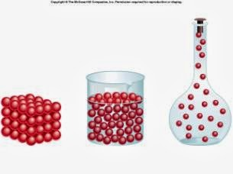

Name: _____________________________________

Homework:

**The Particle Model**

|  |
| --- |
| **Terms:** Physical, Moving, Attracted, Invisible, Particle, Invisible |

1. 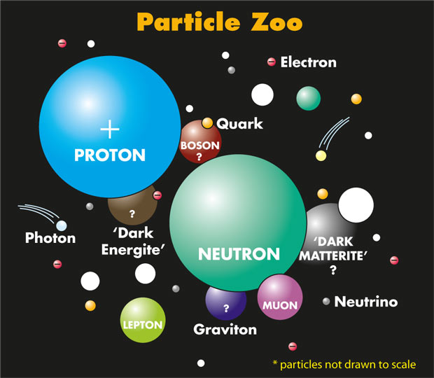Most __________ change can be understood by using the _____________ model. (see image on front of booklet)
2. The particle model assumes that all forms of matter are:
   1. Made up of _____________, ball shaped structures called particles.
   2. Particles are hard and cannot be compressed or _____________.
   3. ___________ to each other.
   4. Constantly _______________

|  |
| --- |
| **Terms:** Shape, Solids, Gases, Freely, Flow, Liquids, Fixed, Tightly, Stuck, Straight, Stuck |

**On the front of your booklet, label each container with the appropriate state of matter.**

1. 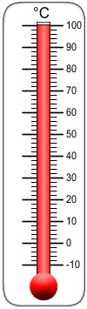The particle attraction varies between different states.
   1. __________________
      1. The particles are not _____________ to each other at all.
      2. Large gaps between particles allow them to move ___________ about the container.
      3. They move in __________ lines until they collide with other particles, or the sides of the container.
   2. ___________________
      1. The particles are packed ______________together.
      2. This allows liquids to ____________, and can take the shape of their container.
      3. The particles vibrate in the liquid, but can also move freely around in the liquid.
   3. ___________________
      1. The particles are ____________ tightly together.
      2. This is why solids hold their own _________very well.
      3. The particles vibrate in a ____________ position.

**Expansion, Contraction and Pressure**

|  |
| --- |
| **Terms:** More, Less, Temperature |

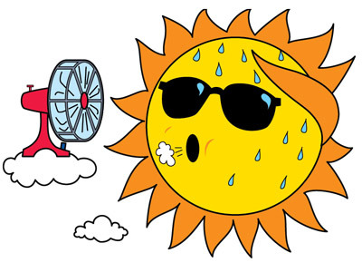Changes in state are caused by changes in ____________. The change in temperature causes particle vibration to either increase or decrease.

* Higher Temperature = _______ Vibration
* Lower Temperature = _______ Vibration

1. **Expansion and Contraction:**

|  |
| --- |
| **Terms:** Decreases, Expand, Contraction, Speed, Slow down, Flexible, Expansion, Increase |

* 1. Gases
     1. ____________**:** Temperature increases cause the particles to increase in _____________. As the particles increase in speed they hit the walls of the container with more force.

____________: As the temperature decreases, the speeds of the particles ____________and hit the walls of the container with less force.

* + - * If the container is ____________ – (like a balloon) the container will ____________ as the temperature increases, and contract as the temperature decreases.
      * If the container is not flexible – the pressure in the container will ____________ as the temperature increases. The pressure will decrease in the container as the temperature ____________.

Draw a gas in a balloon at both low and high temperature. Longer arrows indicate greater speed.

|  |  |  |
| --- | --- | --- |
| **Low Temperature** | **Room Temperature** | **High Temperature** |
|  |  |  |

|  |
| --- |
| **Terms:** Solid, Expansion, Contraction, Escape, Form, Shrinks, Expand |

1. Liquids
   * 1. ____________: Temperature increases cause the particles in liquids to vibrate more and start to __________ as a gas.
     2. Contraction: The temperature decreases cause particles to vibrate less and may start to ___________ a solid.
     3. Since particles in liquids are free to move around, they tend to expand and contract more than __________.
2. Solids
   * 1. Expansion: Temperature increases cause the particles to vibrate more and push the particle further apart. This causes the solid to ____________.
     2. ____________: As the temperature decreases, the particles vibrate less and move closer together. The solid ____________ as a result.

Draw a liquid at the **particle level** that is both cooler and hotter

|  |  |  |
| --- | --- | --- |
| **Low Temperature** | **Room Temperature** | **Higher Temperature** |
|  |  |  |

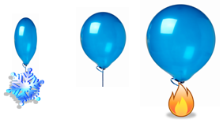

**NOTE:** _____________and______________**OCCURS IN SOLIDS, LIQUIDS AND GASES**

**Changes of State and the Particle Model**

|  |
| --- |
| **Terms:** Liquid, Melting, Particles, Gas, Condensation, Move Slower,  Droplet, Freezing, Evaporation, |

1. **Melting and Freezing**
   1. Solid (____________)
      1. The particles vibrate but are held in place by their attraction towards each other. As the temperature increases the particles vibrate more and it vibrates so vigorously that the attraction the particles have towards each other break and the solid begins to melt to form a liquid.
   2. Liquids (____________)
      1. The exact opposite of melting. As the particles are cooled they move less vigorously and the attraction that they have towards each other holds them together.
2. **Evaporation and Condensation**
   1. Liquid (____________)
      1. When heated, particles escape from the surface of a liquid. The particles are held by only a weak attraction. The hotter the liquid gets, the more ______________ escape (evaporate) from the surface of the liquid to form a _________.
      2. When boiling, the particles start to escape while inside the liquid. This is what we see when the ______________ is bubbling.
   2. Gases (____________)
      1. The opposite of evaporation. As the gas is ______________, the particles start to ___________ __________and soon will form an attraction towards each other. This will then form a liquid ____________.

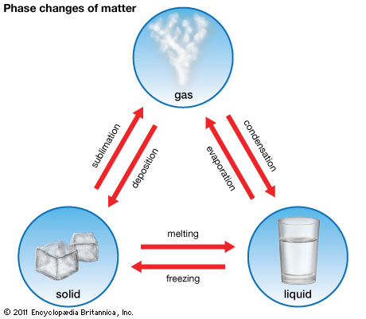

**Diffusion and the Particle Model**

|  |
| --- |
| **Terms:** Mix evenly, diffusion, distributed, zig-sag |

* 1. When the particles of two liquids or gases ____________ ____________together.
  2. This process is known as ____________.
  3. During diffusion, particles travel in a ____________ manner.
  4. Eventually, the particles will be ________________________throughout the container.

Diffusion Demonstration 1:

1. Two herbal tea bags. Two clear glasses or beakers. One tea bag dipped in hot water and the other dipped into cold water.

Diffusion Demonstration 2:

1. Have students pair up. One with a stopwatch and the other person assigned to smell.
2. Have students spread across the room.
3. Choose a perfume or air freshener and without telling the students what the smell is, spray an amount from one corner from the room.
4. Time the spread of the smell throughout the room.

After the demonstration, In the space below, draw how a **single particle** of perfume might **travel** to reach the nose at the other end of the room. The dots indicate particles of air in the room.

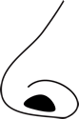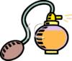

Year 8: Density

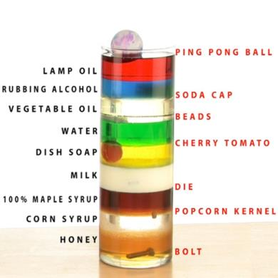

Name: _____________________________________

Homework:

**Density Properties:**

1. Density is a _____________ _____________.
2. A physical property describes an objects:
   1. _____________
   2. _____________ of melting, _____________, and boiling.
   3. _____________ (how easy it is to _____________)
   4. _____________
3. Density measures how much _____________ is packed into a specific _____________.
4. NOTE: It is not the same as weight or _____________.

**Comparing Density:**

1. Density is _____________ by how many grams are in a 1 centimetre _____________.
2. We use the symbol _____________ to represent this.
   1. g = _____________
   2. cm = _____________
   3. 3 = _____________
3. 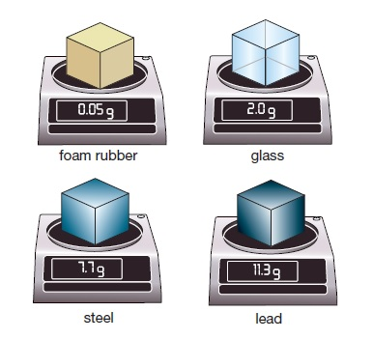See the examples of different densities below and write the names from most dense to least dense.
   1. ___________________,
   2. ___________________,
   3. ___________________,
   4. ___________________,

**Floating and Sinking**

1. Density determines how different substances will _____________ themselves when _____________ together.
2. Cooking oil has a density of 0.85 g/cm3 and water has a density of 1.0 g/cm3. Which liquid will float on top of the other? _____________________
3. Complete the following:
   1. The following rocks are placed into a cup of water. Pumice has a density of 0.64 g/cm3 and Obsidian has a density of 2.35 g/cm3.
   2. Draw a picture showing how the rocks will float or sink in the beaker of water.
   3. Label the rocks and state the densities of all three substances.

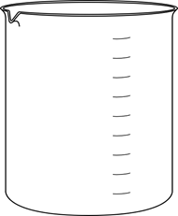

**Mass, Volume and Density**

1. _____________ – determines how much _____________ is in a substance.

We use:

* 1. _____________ – to measure small things like a mouse.
  2. _____________ – to measure heavier things like people.
  3. _____________ – to measure extremely heavy things like airplanes.

1. _____________ – is the amount of _____________ a substance takes up.
   1. We can measure volume by multiplying . . .
   2. _____________ x _____________ x _____________ = Volume
   3. Calculate the volume of the object below.

25 cm

5 cm

10 cm

Height - ______________

Width - ______________ x

Length - _____________ x

________________________

Volume - _____________cm3

**Calculating Density**

1. Density Definition - _________________________________________________
2. We can measure density using the formula below:

 $_____________ =\frac{Mass}{Volume}$

  2. NOTE: When calculating density we must put:
      1. Mass in as _____________
      2. Volume in as _____________
   3. A helpful way to remember how to use the density formula is by using the _____________ _____________.

1. To use it we simply must _____________ up the one we _________ know. And then _____________ or _____________ (as appropriate) the other two that we ________know.
2. Calculate the following:

Mass = 70g

Volume = 8 cm3

Density = _____ g/cm3

1. Complete the following table using the formula triangle. Use a calculator.

|  |  |  |  |
| --- | --- | --- | --- |
| **Density**  (g/cm3) | **Mass**  (g) | **Volume**  (cm3) | **Working** |
|  | 20 | 10 | 20 ÷ 10 = **2 g/cm3** |
| 5 |  | 5 |  |
| 6 | 10 |  |  |
|  | 25 | 8 |  |
| 60 |  | 20 |  |