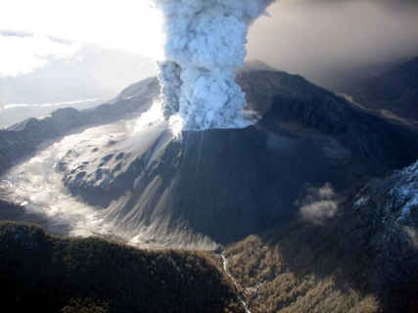
Volcanic Eruptions, Earthquakes and Tsunamis
TASK SHEET
In groups of 2-3 (as assigned by your teacher), you are to design a PowerPoint presentation on a specific event from one of the following topics:
- Volcanic Eruptions
- Earthquakes
- Tsunamis
You will have two-three periods in class, as allocated by your teacher, to work on the presentations before presenting them to the class. (If you would like to bring in/make other resources to aid your presentation, you are to organise these in your own time.)
Content Requirements:
Criteria | Tick when completed
Title slide
What plates and crust were possibly involved
The location of the event with a map
Date and number/ types of casualties
Scale and areas affected by the event
Before and after photos
What type of aid was provided? What were the short and long term affects?
Is the plate/volcano still active and when was the most recent activity?
Any other interesting facts?

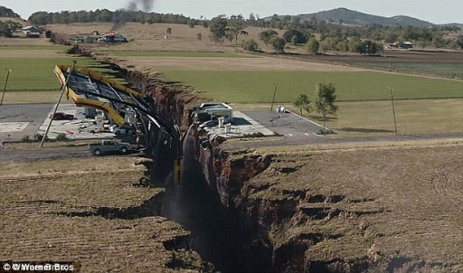
Presentation Requirements:
- Maximum 10 slides
- 4-6 minutes long
- All members must contribute equally
- 1 video allowed (1 minute maximum)
- Balance between pictures and text
- No reading from PowerPoint.
- You must make eye contact regularly with your audience

