Volcanic eruptions
Name: ______________________________
- Where do volcanoes often form? ___________________________________________________________________________
- What melts the earth’s crust and liquefies rock beneath the crust? ___________________________________________________________________________
- Molten rock beneath the crust is called ___________________________________________________________________________
- When the molten rock escapes from the earth it is called ___________________________________________________________________________
- What are hotspots in the earth’s crust? ___________________________________________________________________________
- Clouds of rock, ash and gas that rush down a volcano like an avalanche is known as a ___________________________________________________________________________
- What types of boundaries do volcanoes mostly occur on? ___________________________________________________________________________
- What causes magma to be pushed up and erupt? ___________________________________________________________________________

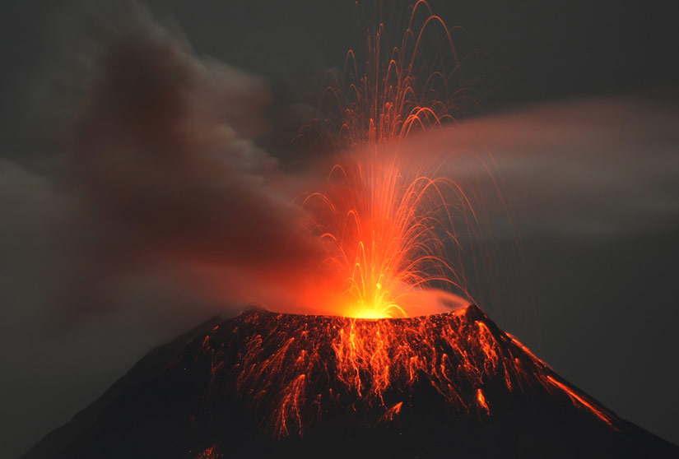
Fill in the blanks
Volcanoes emit:
- Gas such as ____________ and ___________________
- _______________ (fine rock particles)
- ____________ (molten rock)
- Lumps of solid volcanic rock like _____________
Volcanoes form where there are ______________________ in the Earth’s crust and where extremely hot molten rock called ______________ has accumulated below the weak spots.
This magma is occasionally pushed upwards under _______________________ into the volcano.
The magma reaches the surface, and is now known as _______________.
It erupts white hot at a temperature of over _______________________. The lava changes colour as it cools from ______________ through _____________, ___________________and _____________, until it finally becomes a black colour.
The type of magma that is formed will affect what the volcanic eruption is like. The eruption can be ___________________ when the magma:
- Is _______________ (flowing very slowly)
- Contains a lot of ____________ and ___________
The explosions can throw out ‘____________________’ of rock called _____________. Scoria typically has many spaces in it where the gas bubbles have accumulated. The explosions also create a massive __________________________. The ash cloud of a can rapidly rise high enough to be dangerous to aircraft.
