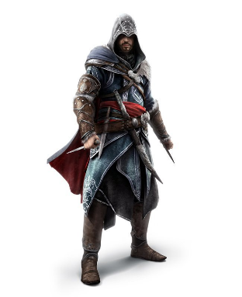
Shenton 3 Assassin’s Guild Rules

Objective:
Eliminate as many targets as possible without getting caught.
Time Allocated:
7 days (Tuesday, 8:45 am – Tuesday 8:30 am)
Weapons:
- Weapon is a popsicle stick. Name of the target is written on the stick. Failure to use the correct weapon results in an INCOMPLETE KILL.
Kills:
- Kills must be DIRECT. This eliminates assassination by throwing or trapping.
- Kills must take place in secrecy with no witnesses.
- If witnesses are present, you must disguise yourself by covering your mouth with your hand prior to attempting the assassination.
- If the hand is moved away from the mouth prior to the assassination being completed it is an INCOMPLETE KILL.
- Kill Zone – Torso of target
- No Kill Zone – Backpack, Limbs
- Illegal Zone – Face, Neck, Groin region
Safe Zones:
- Attempts to assassinate a target inside a safe zone is prohibited and results in a points deduction.
- Safe Zone Places and Times
  - PC (8:30 – 8:45)
  - Student Services (All Times)
Points System:
- Unwitnessed Kill – 10 points
- Disguised Kill – 5 points

Rules:
NOTE: Any disagreements that cannot be resolved between assassin and target are to be referred to the Guild Master. The Guild Master’s decision is final. Failure to accept the decision will result in a ban.
- You must carry your weapon/target with you at all times. Failure to do so results in points penalty.
- Target must be eliminated using the correct weapon.
- Target must be eliminated outside of the SAFE ZONES.
- Target must be ‘hit’ only in the noted ‘kill zone’.
  - If initial contact is made in an ILLEGAL zone, the assassin is penalised points and the kill is not counted. Illegal hits must be referred to the moderator.
  - If initial contact is made in a NO KILL zone, the assassin may strike again without penalty.
- Elimination of a target wearing a SAFE TIE is prohibited. A safe tie is a symbol to indicate that a player is unable to participate that day. Maximum of one day or they are removed from the game.
- If a target becomes aware that they are about to be assassinated, they may defend themselves using their OWN weapon.
- After a successful assassination/self-defense, both members MUST follow the Successful Kill Steps.
Successful Kill Steps:
- Once a valid assassination has taken place, the target must give the assassin their own targets name. This is done by giving them the popsicle stick.
- If the name of the target’s next victim is the assassin, the assassin must report to the Guild Master who will issue a new target.
- The target must always report their own death to the Guild Master during PC on the next day or via email if they are absent.
FAQ
Q: What if I try to assassinate someone and then stuff it up and run away?
Q: What if my assassination results in a no kill?
A: These two questions have the same answer. Now that your target knows who their assassin is, it will make it a lot harder to kill them. You will just have to try again another time.
From the shadows,
The Guild Master
Q: Is there any way to get insta-banned?
A: Yes, a number of ways. 1. Actually kill someone. 2. Hit someone intentionally in an ILLEGAL ZONE 3. Tell people who your target or another assassins target is. 4. ______________________

Q: What is the point of this game?
A: Have a bit of fun. Play if you want to play, but don’t ruin it for others.

Q: What is a points penalty?
A: You get points for each kill. You lose points for breaking the rules.

