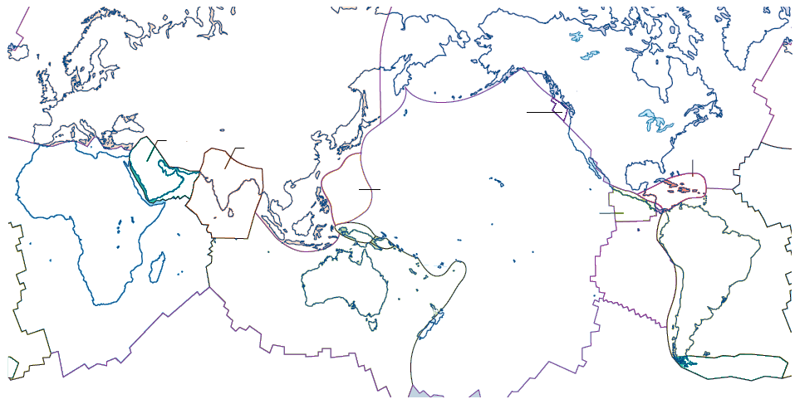
Major Plates of the World (Oxford pg. 120 S or 107 G)

