Year 9 Investigation -
Testing the Strength of Glue

You will be designing an experiment to analyse what the ideal level of a chosen ingredient is when making glue. You and your group will need to decide which ingredient you think will have the most impact on the strength of the glue and design an experiment to test how much of this ingredient should be used.

Choose which ingredient you will vary from the list below:

- The type of milk used- using ordinary, semi-skimmed and skimmed milk.
- The thickness of the glue- the amount of water added.
- The pH level of the glue- using more acidic, neutral, or basic glue.

EQUIPMENT
(NOTE: 1cm³ = 1ml)

Apparatus  - Eye protection  - Each working group requires:  - Spatulas  - Stirring rods  - Measuring cylinders (100 cm³ and 25 cm³)  - Beakers (100 cm³ and 250 cm³)  - Bunsen burner  - Heat resistant mat  - Tripod  - Gauze  - Filter funnel and paper  - Popsticks  - Indicator paper  - Weights (the ones on a hook are ideal) to be added about 100 g at a time  - Sand tray or box of scrunched up newspaper | 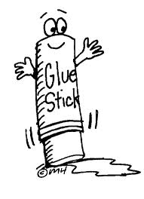 | Chemicals  - Milk  - Acid - Vinegar  - Base – Sodium Hydroxide

PROCEDURE

Making the glue (standard recipe):

- Measure 100 cm³ of milk and 20 cm³ of vinegar into a beaker. Place the beaker on a tripod and gauze and heat over the Bunsen burner.

- Stir constantly until SMALL lumps start to form.

- Stop heating, but keep stirring until no more lumps form.

- Let the lumps settle for about 2 minutes, then decant the liquid from the top.

- Filter the rest of the mixture and keep the solid part (which is called the curds.) Wash the beaker.

- Gently squeeze off any excess liquid from the curds and then put them into the beaker.

- Add 15 cm³ of water and stir until the mixture is smooth.

- Add 2 cm³ of the base stirring thoroughly then check that the mixture is neutral using indicator paper.

Red = Acidic, Green = Neutral, Purple = Basic
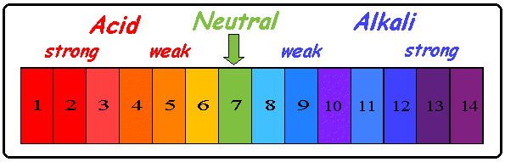
- If it isn’t neutral, add more of the base in 1cm³ increments until it is, stirring thoroughly each time. This is the glue.

- Measure a 2 cm overlap between 2 popsticks and add glue between them.

- Place some tape around the join to ensure they stick together.

- Label the popsticks with the milk or base or amount of water used as well as your group members names.

Testing the glue:

- Arrange two desks 8 cm apart. Lay your glued popsticks so that they form a bridge between the two.

- Hang a weights hook onto the lower of the two popsticks as close to the glued join as you can. Add weights about 10 N at a time and record the force required to break the glue.
NOTES

WARNING! DO NOT BOIL THE MILK AS IT COULD ERUPT.

Note: the lumps are quite tiny

Decant means: _________________________

CARE! The filter paper is quite delicate so you must not accidentally tear it.

_____________________________________________________________________________________________________________________________

You will need at least two sets from each mixture of glue you make.

This depends on the variable you have chosen.

