Exothermic and Endothermic reactions
July 1, 2014
Here at science made simple we are keen to inspire not only the next generation of scientists but also the next generation of science communicators. Supporting work experience students each year is an important part of what we do. Our work experience students get a chance to see a range of the activities that science made simple is involved with and we always set them challenge to produce some science communication themselves, whether designing a demo, delivering a short presentation or, in this case, writing a blogpost that includes all of these!
We hope you enjoy this from one of our latest work experience students, Bilaal, we loved having him in the office and think he’s got a promising career ahead of him.
————————————————————————————————————————–
This blogpost looks at two types of reactions: exothermic and endothermic. We’ll also be looking at reversible reactions– reactions in which the products can react to remake the original reactants. Plus, a great demonstration of an exothermic reaction.

Exothermic reactions
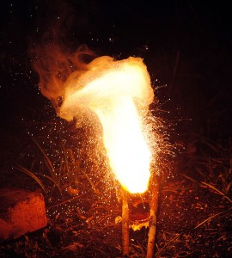
An exothermic reaction (the thermite reaction) using Iron (III) Oxide. The sparks flying outwards are drops of molten iron trailing. Image: Nikthestunned, CC-BY-SA

An exothermic reaction occurs when the energy used to break the bonds in the reactants (the starting stuff) is less than the energy released when new bonds are made in the products (the stuff you end up with). This extra energy is given off as heat and there is a temperature rise around the surroundings of the reaction.
Combustion is an example of an exothermic reaction- you can feel the heat given off if you get too close!

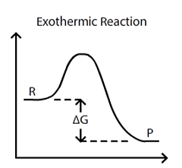
Shamsher Singh CC-BY-SA

This graph shows that energy has been released and Delta G (energy change) is negative.
The reactants have more energy than the end products. It also indicates that the enthalpy change is negative as heat is lost to the surroundings resulting in a temperature increase.

Endothermic reactions
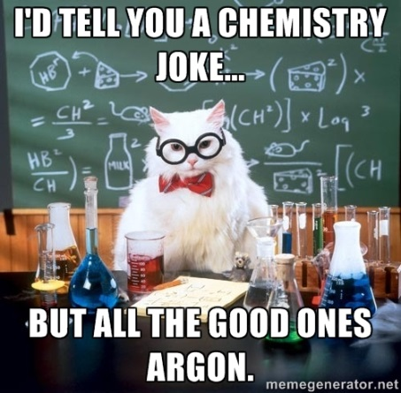
Cool chemistry cat! CC-BY-SA www.knowyourmeme.com
An endothermic reaction occurs when the energy used to break the bonds in the reactants is greater than the energy given out when bonds are formed in the products. This means that overall the reaction takes in energy, therefore there is a temperature decrease in the surroundings.
Electrolysis is an example of an endothermic reaction but you can create one easily in the kitchen just by dissolving salt or sugar in water. If you use cold water and lots of salt you can even make ice-cream see our Cool Chemistry blogpost for more details.

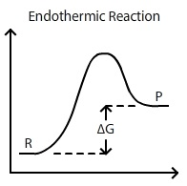
Shamsher Singh CC-BY-SA

This graph shows that energy has been taken in and Delta G is positive.
Similarly, this endothermic chart shows that the reactants start off with less energy this time and the end products have absorbed energy. Clearly shown in the diagram, enthalpy change of the reaction is positive because energy is being taken in from the surroundings which results in a temperature decrease.

