Year 9 Heat Comprehension Quiz Name: ANSWERS

- Draw an arrow to show how heat travels between the heat source and the objects. State what the method of heat transfer is. (6 points)
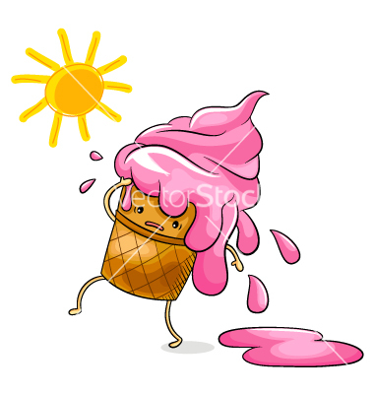 | 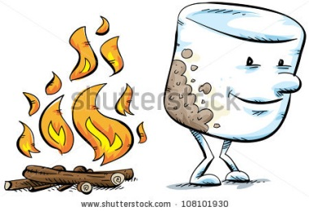 | 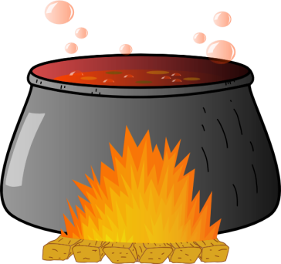
Radiation | Radiation | Convection OR Conduction

- What form does radiation travel in? Electromagnetic Waves (2 points)
- Connect the word on the left to the correct term on the right which describes how radiation interacts with different objects and surfaces. (3 points)
Dark |  | Reflected
Light |  | Absorbed
Clear |  | Transmitted

- Which non solid objects can technically conduct heat as well but is very inefficient. Liquids and Gases (2 point)
- Draw a picture showing how a convection current (sea breeze) occurs between the land and the sea. Label the arrows and objects appropriately. (6 points) (Land, Heat, Cold, Sea = 4 points; Arrows = 2 points)

(4+2+2+3 = 11 points)
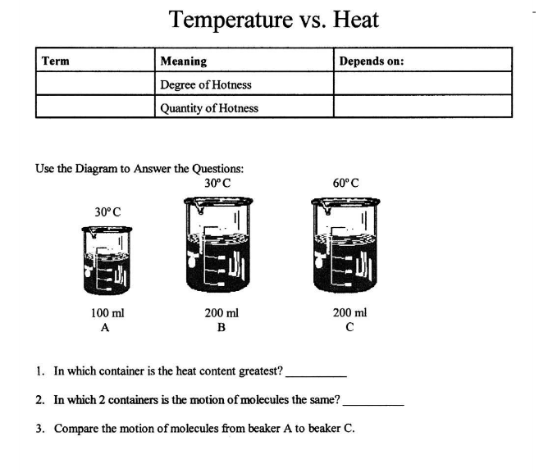
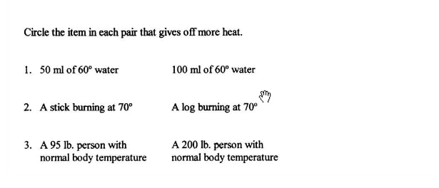
$${}/{30}$$

