Year 9 Heat Comprehension Quiz Name: ______________________

- Draw an arrow to show how heat travels between the heat source and the objects. State what the method of heat transfer is. (6 points)
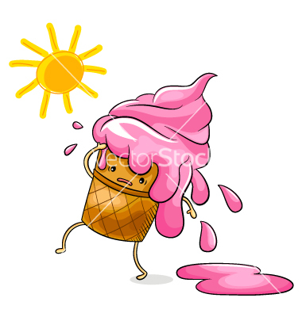 | 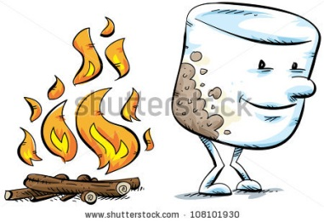

- What form does radiation travel in? _____________________________ (2 points)
- Connect the word on the left to the correct term on the right which describes how radiation interacts with different objects and surfaces. (3 points)
Dark |  | Reflected
Light |  | Absorbed
Clear |  | Transmitted

- Which method of Heat Transport can technically conduct heat as well but is very inefficient. _______________________ (2 point)
- Draw a picture showing how a convection current (sea breeze) occurs between the land and the sea. Label the arrows and objects appropriately. (6 points)

(4+2+2+3 = 11 points)
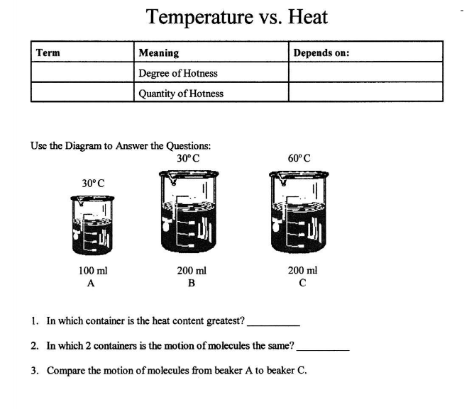
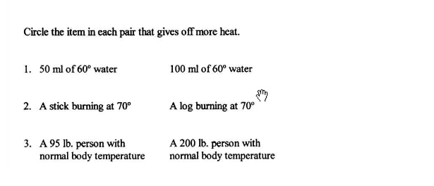
$${}/{30}$$

