Year 8

Energy Revision Booklet

Name: ____________________________________________

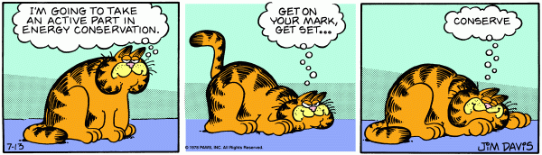

Types of energy Name: ____________________________

1. The two basic types of energy

Directions: Determine the best match between basic types of energy and the description provided. Put the correct letter in the blank.

- Kinetic
- Potential
- Both forms of energy

___b___1. A skier at the top of the mountain
___b___2. Gasoline in a storage tank
___a___3. A race-care traveling at its maximum speed
___c___4. Water flowing from a waterfall before it hits the pond below
___b___5. A spring in a pinball machine before it is released
___c___6. Burning a match
___a___7. A running refrigerator motor

2. Definitions of Energy

Directions: Write down the definition for each of the following terms.

ENERGY:
The capacity for doing work. It may exist in potential, kinetic, thermal, electrical, chemical, nuclear, or other various forms.

KINETIC ENERGY:
Kinetic energy is defined as the energy of movement. Whenever objects or people move they are using kinetic energy.

POTENTIAL ENERGY:
Potential energy is energy that is stored in objects and is waiting to be used. This stored energy can be the result of a change of shape (stretching or squashing) or an objects height above ground (gravitational), or stored in molecular bonds (chemical energy) or in the centre of an atom (nuclear energy).
3. Types of Energy

Directions: Draw an arrow to connect the type of energy to its definition. Also identify each energy as kinetic (KE) or potential (PE) and give an example.

KE or PE | Type of energy |  | Definition | Example
KE | Heat |  | Movements of photons | Light bulb
KE | Light |  | Vibration of waves through material | A siren sounding
PE | Gravitational |  | Energy that is stored by stretching or squashing | Pogo stick
KE | Sound |  | Movement of electrons | The electricity flowing from a power point to an electric fan
PE | Chemical |  | Energy which transfers among particles by means of kinetic energy of those particles | The heat from a fire heating up a pot of water
PE | Nuclear |  | Energy of position or height | Lifting up a chair and putting it on a desk
KE | Electrical |  | Energy stored in bonds of atoms and molecules | A burger
PE | Elastic |  | Stored in the nucleus of an atom; released when nucleus splits or combines | Uranium being used in a nuclear power plant

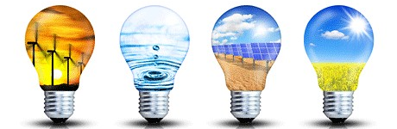
4. Forms of Energy Continued

Directions: Match the energy form(s) to the description provided. A few questions may have more than one answer.

____d a______1. Falling rocks from the top of a mountain (a) Kinetic
____h c _____2. Release of energy from the Sun (b) Electrical
____a c g____3. Energy released from food after it is eaten (c) Heat
_____e_______4. Batteries (d) Gravitational
_____b ______5. The energy that runs a refrigerator (e) Chemical
_____f_______6. Nuclear fission reactors (f) Nuclear
_____g______7. The rumble of thunder from a storm (g) Sound
____c g a___8. Rubbing your hands together (h) Light
______e______9. Gasoline (i) Elastic
___i g c _____10. Bouncing on a trampoline
______e _____11. Food before it is eaten
____c h g____12. Lightening
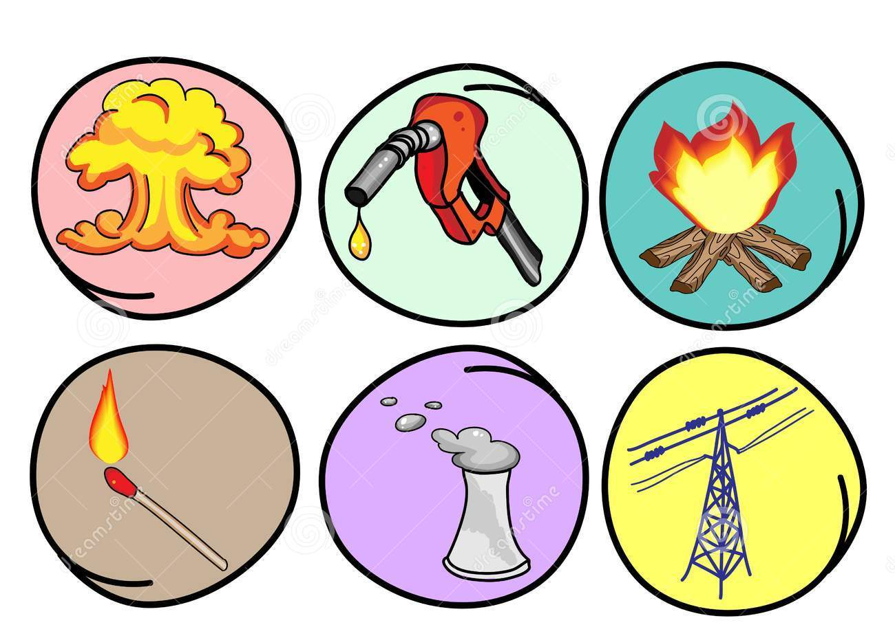
_____a g_____13. Releasing an elastic band
Energy Transfer and Transformation

Define the Law of Conservation:

Energy cannot be created or destroyed

Define Energy Transfer:

When the same type of energy is passed from one object to another.

Draw a flow diagram showing the objects through which energy is travelling. Circle the energy transfer.

- A torch

Ex, Battery wires light globe

- A fan (connected to the wall)

______wires______________ ________motor____________ ___air or blades_

- An Iphone (listening to music)

_________Battery___ _______wires_______ ___speaker______ ____air______

- A moving car

_____battery______ wires motor ______wheels_______

- A Tram or Electric Train

Wires ______motor________ wheels

Define Energy Transformation;

When energy is CHANGED from one TYPE of energy to ANOTHER TYPE of energy.

Draw a flow diagram for each of the following energy transformations (remember you are representing the energy transformations- only use the energy types);

ANSWERS may vary; with variations students should be able to explain their answers.

- A torch

Ex, Chemical Potential Energy Electrical Energy Light Energy

- A fan (connected to the wall)

_____ electrical energy_______ ____kinetic energy of motor turning______ _____kinetic energy of air or blades_

- An Iphone (listening to music)

_____ chemical potential energy_____ ___electrical energy____ ___kinetic energy__ sound energy

- A moving car

Chemical potential energy____ Electrical Energy Chemical potential energy __kinetic energy of wheels____

- A Tram or Electric Train

Electrical energy__ ___kinetic energy of motor___ __kinetic energy of wheels___

- What is the difference between Energy Transformation and Energy Transfers?

Energy TRANSFER is when energy is when the SAME ENERGY is PASSED from one object to another whereas energy TRANSFORMATION is when energy CHANGES TYPE/FORM.
_____________________________________________________________________________________________

- Suggest one way that energy can be transferred without being transformed.

Answers may vary. Make sure the energy type is the same in passing from one object to the next. Examples could include falling dominos (kinetic to kinetic), kicking a ball (kinetic to kinetic).
_____________________________________________________________________________________________

Flow Diagrams

- How do we represent an energy transformation scientifically?

We use FLOW diagrams to represent transformation scientifically _____________________________________________________________________________________________

- What are the 3 ways that flow diagrams help show transformation? (hint: look at page 48)

- The arrow points in the direction of the transformation
- The energy input is written at the back of the arrow.
- The useful energy input is written at the tip of the arrow.
_____________________________________________________________________________________________

- Why is the direction the arrows point in a flow diagram important?

The arrow points in the direction of the transformation

Energy Efficiency

E= (O/I ) X 100 | O= (E X I) /100 | I= (O/E) X 100

× 1000

Joules kilojoules

÷ 1000

- Convert the following into joules.

1.5 kJ = 1500 J | 3.4 kJ = 3400 J
154 kJ = 154 000J | 256 kJ = 256 000 J
0.2 kJ = 200 J | 0.638 kJ = 638J

- Convert the following into kilojoules.

5 J = 0.003 kJ | 27 J = 0.027 kJ
2047 J = 2.047 kJ | 156 J = 0.156 kJ
0.4 J = 0.0004 kJ | 0.564 J = 0.000564 kJ

- Recall the Law of Conservation of Energy and write it out below.
Energy cannot be created or destroyed, only transferred or transformed.

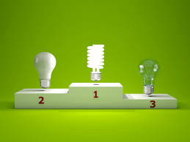

- Use the words in the box below to fill in the blanks.

surroundings | heat | transferred | wasted
heat | energy | sound | usefully

When devices transfer energy only part of it is usefully transferred to where it is wanted.

The rest of the energy is transferred in some non-useful way or wasted.

Usually the energy is wasted to the surroundings as heat

The energy that is wasted does not disappear; it is changed into a non-useful form.

The non-useful energy in a light bulb is heat.

The non-useful energy from a car is heat and sound.

- For the following devices, work out the missing information.

Device and amount of energy supplied to it | Useful energy produced | Wasted energy
Filament light bulb 100 J | 20 J as light | 80 J as heat
Low energy light bulb 25 J | 20 J as light | 5 J as heat
Electric drill 500 J | 300 J as kinetic (movement) energy | 200 J as heat
Television 200 J | ______ J as light and sound | 150 J as heat

- Use the words in the box to fill in the blanks, and then answer the question.

more | wasted | energy | efficient

The greater the proportion of energy supplied to a device that is usefully transferred, the more efficient the device is.

A car engine is 20% efficient. This means that a lot more energy is wasted than is used to drive the car forward.

A microwave is 60% efficient. This means that out of every 100 joules of electrical energy supplied, 60 joules are used to heat the food. What happens to the other 40 joules?
They are transformed into sound and light energy and lost to the environment.
- Identify what each of the symbols below represent:
E=Efficiency
O=Useful output energy
I= Input energy

- Complete the table below showing the input and output energy and the efficiency of each of the devices.
Item | Total input energy | Useful output energy | Efficiency
Electric Drill | 300 000 J | 28 000 J | 9.3%
Hair Straightener | 30 kJ | 15 000 J | 50%
Petrol Engine | 100 kJ | 2.5 kJ | 2.5%
Steam Engine | 250 kJ | 100 000 J | 40%
Torch | 2 kJ | 0.5 kJ | 25%
Electric motor | 10 kJ | 6400 J | 64%

- Some timber containing 32kJ of energy is used in a fireplace to heat a house. If the transfer from the timber to the house is 70% efficient:

- Calculate the useful output energy. Show all working.
I= 32kJ | O= (E X I) /100
E= 70% | O= (70 X 32) /100
 | O= 22.4 kJ

- Discuss where the wasted energy went.
It was transformed into light and sound energy and lost to the environment.

- Draw out an energy chain showing the energy transformations that will take place.
sound

Chemical heat

light

- A train is supplied with 520 kJ of energy.

- What type of energy is the useful output energy of a train (be specific).
Motion (kinetic)
- If 370 000 J are transformed into heat and sound energy, how many joules of useful output energy would there be? Show your working.
520 000 – 370 000 = 150 000 J

- Calculate the efficiency of the train. Show all working.
I= 520 000J | E= (O/I ) X 100
O= 150 000 J | E= (150 000/520 000) X 100
 | E= 28.85%

- Analyse the diagram below then use your understanding of the Law of Conservation of Energy and Energy Efficiency to explain what is happening.

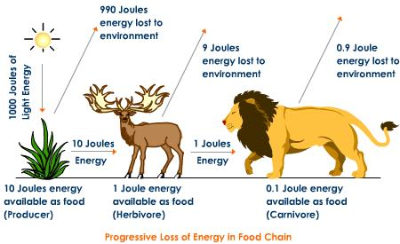

- Each time the energy is transferred, the majority is lost to the environment
- The chemical energy that’s lost has transformed into heat energy
- None of the energy is destroyed, it’s either transferred onto the next animal or transformed into heat energy.
- Likewise, no energy is created. Everything gains energy by having it transferred to them by another animal/plant/the sun.
- The sun gets its energy from all of the STORED chemical energy it has.
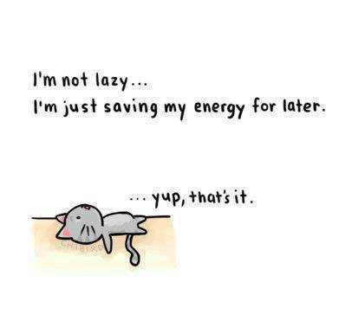

Renewable and Non-Renewable Energy – Revision booklet
- Which of the following would be classified as a renewable resource?
- A barrel of oil that would take 8 million years to form.
- A large piece of coal that would take 4 million years to form.
- Solar rays from the Sun that take 8 minutes to reach the Earth.
- Methane gas from the ocean floor that takes 7 thousand years to outgas.

- One advantage of solar energy is that it:
- is not renewable
- is efficient in any climate
- is available at all times
- is non-polluting.

- Coal, oil, natural gas, and propane are fossil fuels. They are called fossil fuels because:
- They are non-renewable and will run out
- They are burned to release energy and they cause air pollution
- They were formed from the buried remains of plants and tiny animals that lived hundreds of millions of years ago
- They are mixed with fossils so they will burn better

- The burning of fossil fuels produces ________________.
- Sulphur and nitrates in atmosphere
- CO₂
- Acid Rain
- All of the above

- What does wind directly turn to generate electricity?
- Generator
- Motor
- Turbine
- Engine

- What is an advantage of using fossil fuels?
- They are clean and non-polluting
- They will never run out
- They generate large amounts of electricity relatively cheaply

- Which energy form uses uranium or plutonium to create energy?
- Nuclear Power
- Hydroelectric Power
- Solar Power
- Which form of renewable energy would most likely get complaints about noise pollution?
- Solar Power
- Wave Power
- Wind Power

- Define a renewable energy resource? Give three examples.
These are energy sources that are unlimited (will never run out) and once used are rapidly replenished (continuously replaced). Examples: wind, water, geothermal and solar.
- Define a non-renewable energy resource? Give three examples.
Non-renewable energy is the name given to energy sources which once used cannot be replaced. Examples: Natural gas, nuclear fuels, coal, oil

- Indicate which of the following energy sources are renewable OR Non-renewable.
Energy source | RENEWABLE (R) or NON-RENEWABLE (NR)
Coal | NR
Solar | R
Wind | R
Wood | R
Uranium | NR
Natural gas | NR

- What are the main advantages and disadvantages of the following sources of energy?
Source of energy | Advantage | Disadvantage
Gas | - Easy to extract  - Requires little processing  - Is the cleanest of the fossil fuels | - Produces greenhouse gases and atmospheric pollutants when burned.
Nuclear | - Small amounts produce a lot of energy  - Little waste  - No atmospheric pollutants or greenhouse gases produced. | - The waste produced can be very dangerous and needs to be disposed of carefully  - The risk of a nuclear accident can be catastrophic
Wind | - It’s free  - No waste products | - Wind is unpredictable  - Wind farms don’t look great and are noisy

- Compare and contrast biomass, geothermal, oil and coal in terms of the following criteria: renewable or non-renewable resource, advantages and disadvantages. Your answer should include a table.
Name | Description | Advantages | Disadvantages
Coal | Non-Renewable | - Easy and inexpensive to extract  - Is the most abundant of the fossil fuels | - Mining is bad for the environment  - Burning the coal produces greenhouse gases and atmospheric pollutants  - Expensive measures in place to combat the greenhouse gases.
Oil (Petroleum) | Non-Renewable | - Easily converted to energy  - Easy to extract  - Easy to transport | - Lots of greenhouse gases and atmospheric pollutants let off when it’s burnt.  - Accidents during extraction, refining or transport causes major atmospheric pollution
Biomass | Renewable | - Is renewable as long as the trees and plants are replaced.  - Is cheap and easily attained. | - Produces greenhouse gases when burnt.
Geothermal | Renewable | - No fuel needed  - No greenhouse gasses produced | - Limited sites available  - Some sites release dangerous gasses which require safe disposal

