Year 8

Energy Revision Booklet

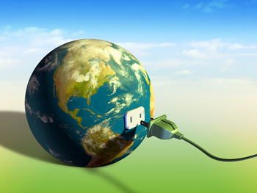

Name: ____________________________________________

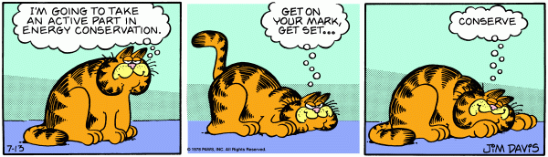

Types of energy

1. The two basic types of energy

Directions: Determine the best match between basic types of energy and the description provided. Put the correct letter in the blank.

- Kinetic
- Potential
- Both forms of energy

______1. A skier at the top of the mountain
______2. Gasoline in a storage tank
______3. A race-care traveling at its maximum speed
______4. Water flowing from a waterfall before it hits the pond below
______5. A spring in a pinball machine before it is released
______6. Burning a match
______7. A running refrigerator motor

2. Definitions of Energy

Directions: Write down the definition for each of the following terms.

ENERGY:

KINETIC ENERGY:

POTENTIAL ENERGY:

3. Types of Energy

Directions: Draw an arrow to connect the type of energy to its definition. Also identify each energy as kinetic (KE) or potential (PE) and give an example.

KE or PE | Type of energy |  | Definition | Example
 | Heat |  | Movements of photons
 | Light |  | Vibration of waves through material
 | Gravitational |  | Energy that is stored by stretching or squashing
 | Sound |  | Movement of electrons
 | Chemical |  | Energy which transfers among particles by means of kinetic energy of those particles
 | Nuclear |  | Energy of position or height
 | Electrical |  | Energy stored in bonds of atoms and molecules
 | Elastic |  | Stored in the nucleus of an atom; released when nucleus splits or combines

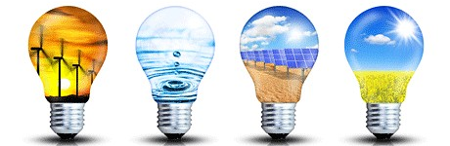
4. Forms of Energy Continued

Directions: Match the energy form(s) to the description provided. A few questions may have more than one answer.

_____________1. Falling rocks from the top of a mountain (a) Kinetic
_____________2. Release of energy from the Sun (b) Electrical
_____________3. Energy released from food after it is eaten (c) Heat
_____________4. Batteries (d) Gravitational
_____________5. The energy that runs a refrigerator (e) Chemical
_____________6. Nuclear fission reactors (f) Nuclear
_____________7. The rumble of thunder from a storm (g) Sound
_____________8. Rubbing your hands together (h) Light
_____________9. Gasoline (i) Elastic
_____________10. Bouncing on a trampoline
_____________11. Food before it is eaten
_____________12. Lightening
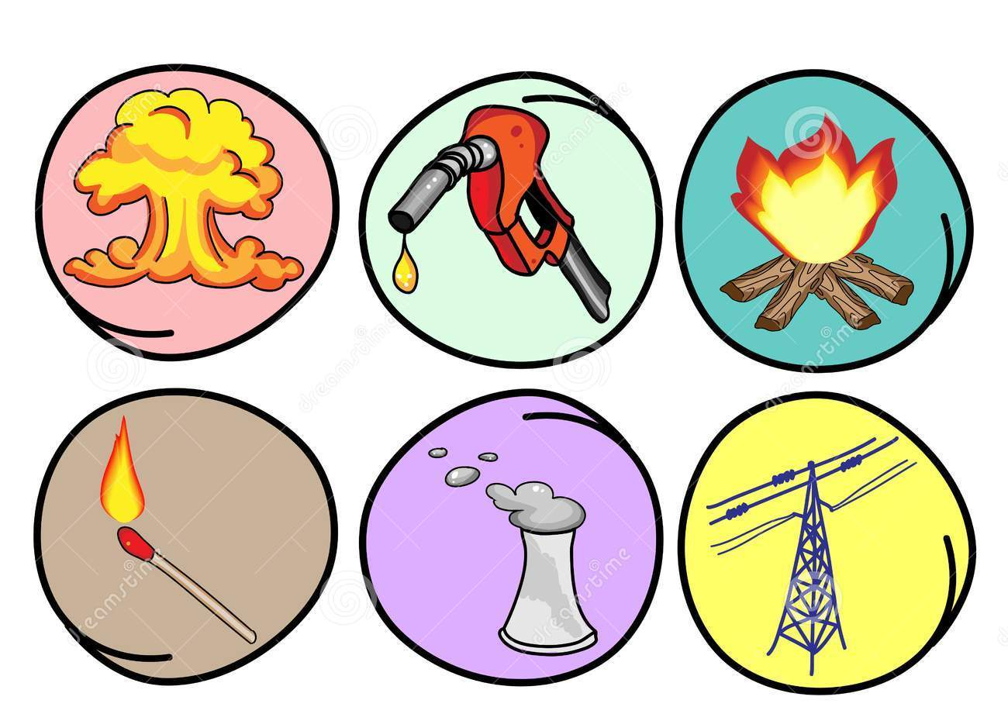
_____________13. Releasing an elastic band

Energy Transfer and Transformation

Define the Law of Conservation:

Define Energy Transfer:

Draw a flow diagram showing the objects through which energy is travelling. Circle the energy transfer.

- A torch

Ex, Battery wires light globe

- A fan (connected to the wall)

____________________ ____________________ ____________________

- An Iphone (listening to music)

____________________ ____________________ ____________________ ____________________

- A moving car

__________________ wires motor ____________________

- A Tram or Electric Train

Wires ____________________ wheels

Define Energy Transformation;

- Draw a flow diagram for each of the following energy transformations (remember you are representing the energy transformations- only use the energy types);

- A torch

Ex, Chemical Potential Energy Electrical Energy Light Energy

- A fan (connected to the wall)

____________________ ____________________ ____________________

- An Iphone (listening to music)

____________________ ____________________ ____________________ ____________________

- A moving car

________________ Electrical Energy Chemical potential energy ________________

- A Tram or Electric Train

____________________ ____________________ ____________________

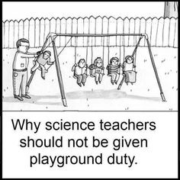

- Contrast between Energy Transformation and Energy Transfers?
_______________________________________________________________________________________________________________________________________________________________________________________________________________________________________________________________________________________
_______________________________________________________________________________________________________________________________________________________________________________________________________________________________________________________________________________________

- Suggest one way that energy can be transferred without being transformed.
_______________________________________________________________________________________________________________________________________________________________________________________________________________________________________________________________________________________

- How do we represent an energy transformation scientifically?
_______________________________________________________________________________________________________________________________________________________________________________________________________________________________________________________________________________________

- What are the 3 ways that flow diagrams help show transformation? (hint: look at page 48)

_______________________________________________________________________________________________________________________________________________________________________________________________________________________________________________________________________________________
_______________________________________________________________________________________________________________________________________________________________________________________________________________________________________________________________________________________

- Why is the direction the arrows point in a flow diagram important?
_______________________________________________________________________________________________________________________________________________________________________________________________________________________________________________________________________________________

Energy Efficiency

E= (O/I ) X 100 | O= (E X I) /100 | I= (O/E) X 100

× 1000

Joules kilojoules

÷ 1000

- Convert the following into joules.

1.5 kJ = _____________________ J | 3.4 kJ = _____________________ J
154 kJ = ____________________ J | 256 kJ = ____________________ J
0.2 kJ = _____________________ J | 0.638 kJ = __________________ J

- Convert the following into kilojoules.

5 J = _____________________ kJ | 27 J = _____________________ kJ
2047 J = __________________ kJ | 156 J = ____________________ kJ
0.4 J = ____________________ kJ | 0.564 J = __________________ kJ

- Recall the Law of Conservation of Energy and write it out below.
__________________________________________________________________________________________
__________________________________________________________________________________________
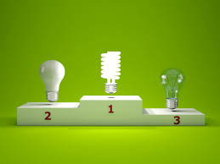

- Use the words in the box below to fill in the blanks.

surroundings | heat | transferred | wasted
heat | energy | sound | usefully

When devices transfer ____________, only part of it is _______________ transferred to where it is wanted.

The rest of the energy is ________________ in some non-useful way or wasted.

Usually the energy is wasted to the _____________________ as ____________.

The energy that is _________________ does not disappear; it is changed into a non-useful form.

The non-useful energy in a light bulb is ____________ .

The non-useful energy from a car is heat and ______________.

- For the following devices, work out the missing information.

Device and amount of energy supplied to it | Useful energy produced | Wasted energy
Filament light bulb 100 J | 20 J as ___________ | ______ J as heat
Low energy light bulb 25 J | ___J as light | 5 J as heat
Electric drill 500 J | _____ J as kinetic (movement) energy | 200 J as __________
Television 200 J | ______J as light and sound | 150 J as __________

- Use the words in the box to fill in the blanks, and then answer the question.

more | wasted | energy | efficient

The greater the proportion of _______________ supplied to a device that is usefully transferred, the ________________ efficient the device is.

A car engine is 20% ___________________ . This means that a lot more energy is _______________ than is used to drive the car forward.

A microwave is 60% efficient. This means that out of every 100 joules of electrical energy supplied, 60 joules are used to heat the food. What happens to the other 40 joules?
__________________________________________________________________________________________
__________________________________________________________________________________________
__________________________________________________________________________________________

- Identify what each of the symbols below represent:
E=_______________________________________
O=_______________________________________
I= _______________________________________

- Complete the table below showing the input and output energy and the efficiency of each of the devices.
Item | Total input energy | Useful output energy | Efficiency
Electric Drill | 300 000 J | 28 000 J
Hair Straightener | 30 kJ | 15 000 J
Petrol Engine | 100 kJ | kJ | 2.5%
Steam Engine | 250 kJ | J | 40%
Torch | kJ | 0.5 kJ | 25%
Electric motor | kJ | 6400 J | 60%

- Some timber containing 32kJ of energy is used in a fireplace to heat a house. If the transfer from the timber to the house is 70% efficient:

- Calculate the useful output energy. Show all working.

- Discuss where the wasted energy went.
__________________________________________________________________________________
__________________________________________________________________________________

- Draw out an energy chain showing the energy transformations that will take place.

- A train is supplied with 520 kJ of energy.

- What type of energy is the useful output energy of a train (be specific).
__________________________________________________________________________________

- If 370 000 J are transformed into heat and sound energy, how many joules of useful output energy would there be? Show your working.

- Calculate the efficiency of the train. Show all working.

- Analyse the diagram below then use your understanding of the Law of Conservation of Energy and Energy Efficiency to explain what is happening.

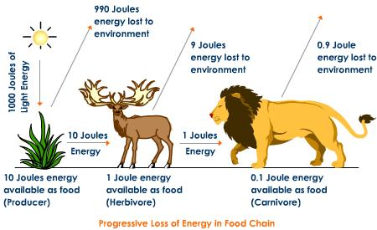

__________________________________________________________________________________________
__________________________________________________________________________________________
__________________________________________________________________________________________
__________________________________________________________________________________________
__________________________________________________________________________________________
__________________________________________________________________________________________

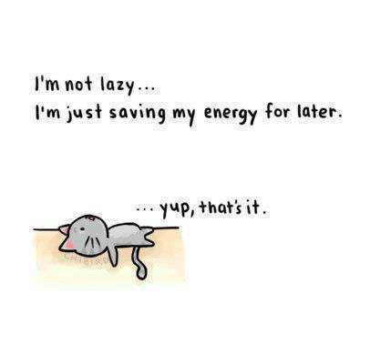

Renewable and Non-Renewable Energy – Revision booklet

- Which of the following would be classified as a renewable resource?
- A barrel of oil that would take 8 million years to form.
- A large piece of coal that would take 4 million years to form.
- Solar rays from the Sun that take 8 minutes to reach the Earth.
- Methane gas from the ocean floor that takes 7 thousand years to outgas.

- One advantage of solar energy is that it:
- is not renewable
- is efficient in any climate
- is available at all times
- is non-polluting.

- Coal, oil, natural gas, and propane are fossil fuels. They are called fossil fuels because:
- They are non-renewable and will run out
- They are burned to release energy and they cause air pollution
- They were formed from the buried remains of plants and tiny animals that lived hundreds of millions of years ago
- They are mixed with fossils so they will burn better

- The burning of fossil fuels produces ________________.
- Sulphur and nitrates in atmosphere
- CO₂
- Acid Rain
- All of the above

- What does wind directly turn to generate electricity?
- Generator
- Motor
- Turbine
- Engine

- What is an advantage of using fossil fuels?
- They are clean and non-polluting
- They will never run out
- They generate large amounts of electricity relatively cheaply

- Which energy form uses uranium or plutonium to create energy?
- Nuclear Power
- Hydroelectric Power
- Solar Power

- Which form of renewable energy would most likely get complaints about noise pollution?
- Solar Power
- Wave Power
- Wind Power

- Define a renewable energy resource? Give three examples.

- Define a non-renewable energy resource? Give three examples.

- Indicate which of the following energy sources are renewable OR Non-renewable.
Energy source | RENEWABLE (R) or NON-RENEWABLE (NR)
Coal
Solar
Wind
Wood
Uranium
Natural gas

- What are the main advantages and disadvantages of the following sources of energy?

Source of energy | Advantage | Disadvantage
Gas
Nuclear
Wind

- Compare and contrast biomass, geothermal, oil and coal in terms of the following criteria: renewable or non-renewable resource, advantages and disadvantages. Your answer should include a table.

