*Set up a timer and complete the following revision questions.
Main Points:
- Write in 5 key points from memory. Fill in as much detail as you can. (5 minutes)
- Refer to your notes to complete any missing information. (5 minutes)

1.

2.

3.

4.

5.
- Write a test question for yourself using Blooms Taxonomy and answer it in as much detail as you can. (5 minutes)

Question:
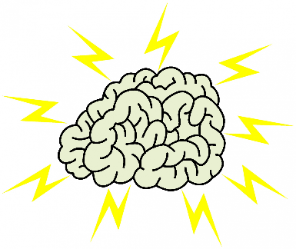

Answer:

Study Tip: Take your questions and answer to your teacher during an appropriate break and ask them to review it.

