Design an Investigation
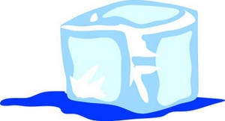
Your Name: ____________________
Group members:
_______________________
_______________________

Urea is a colourless, crystalline compound that undergoes an endothermic reaction when dissolved in water. This means that when it is mixed with water, it sucks in heat from the surrounding area, making it seem very cold.
A company wants to use this product and sell it under the name of COLDEX. In order to comply with the ACCC, the company needs you to test the compound’s reaction then record and present the data.
You will need to design an investigation which you are to conduct in a group, using the scientific method. You will test the effects of different amounts of urea on the temperature of the reaction. You will design all parts of your investigation.
- Hypothesis
- Available materials
- Beaker
- Measuring Cylinder
- Thermometer
- Scale
- Urea (Coldex)
- Spatula

- Method (so someone else could follow it)
- Variables; independent, dependent, control
- Table for results and Graph to represent them on.

Note: After obtaining the results in class, you will then write up your investigation as an individual the following lesson. This will be assessed.

