Year 8 Science
Chemistry Revision Booklet

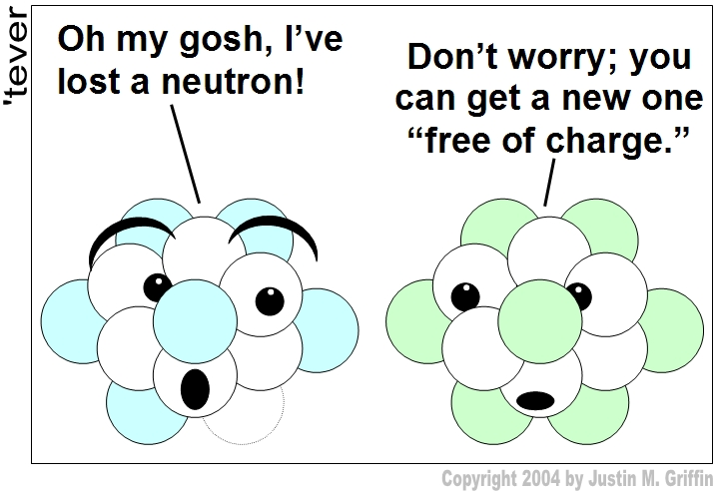

Name: _________________________________

Test: Week

Atoms
Oxford textbook chapter 4.6 (page 72 – 73)

- According to the particle model which of the following is correct?

- All matter is made of atoms that have no mass and are too small to be seen with the naked eye.
- Some matter is made of atoms that have mass and are small, but can be seen with the naked eye.
- All matter is made of atoms that have mass and are small, but can be seen with the naked eye.
- All matter is made of atoms that have mass but are too small to be seen with the naked eye.

- According to John Dalton’s model of atoms, which of the following is incorrect?

- Atoms cannot be created or destroyed, and are indivisible.
- All matter consists of tiny particles called atoms.
- All atoms of the same element are identical, but different from atoms of other elements.
- Atoms lose their identities when they combine to form compounds.

- Write a definition for an atom.

- Name the particles, and the charge of each particle, you would find in an atom.
a) __________________________________
b) __________________________________
c) __________________________________

- What other differences are there between these three particles?

- Label the following diagram of an atom using the following words:
nucleus, electron and electron shell
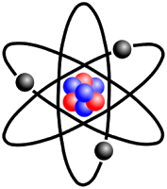

- Give a definition of atomic number.

- Give a definition of atomic mass.

- Complete the following table (note – round your answers to whole numbers)

Element | Number of Protons | Number of Electrons | Number of Neutrons | Electron Configuration
Potassium
Sulphur
Aluminium
Fluorine
Argon
Silicon
Oxygen
Phosphorous
Beryllium

- Draw a diagram, showing the number of protons, neutrons and electrons for the following atoms.

Boron Magnesium

Nitrogen Chlorine

Neon Calcium

The Periodic Table

- Define a family (group). ____________________________________________________

- What is a period? ________________________________________________________

- What is the symbol for the following elements?

  - Magnesium _____________ b. Potassium ______________

c. Argon _______________ d. Fluorine ____________

- What are the names of the following elements?

a. C __________________ b. Cl _________________

c. Be _________________ d. Li _________________

- What period are the following elements in?

a. He _______________ b. Ge _________________

c. Rb _______________ d. I __________________

- What group are the following elements in?

a. Sulfur _______________ b. Ca _________________

c. Iodine _______________ d. Fe _________________

- What is the atomic symbol for Aluminium? ______________

- P is the symbol for what element? _________________________________

- The element that has the atomic number 17 is? _____________________________

- List the symbols for two transition metals: ________________ and __________________

- Use the words below to fill in the blanks.

corrosion | potassium | malleable | solids | nitrogen
metal-like | better | dull | stretched | brittle
ductile | good | shiny | gases | silicon
poor | worse | hydrogen | boron | calcium

METALS:

- Metals are _______________conductors of heat and electricity.
- Metals are _________________ in appearance.
- Metals are ductile (can be ___________________ into thin wires).
- Metals are ___________________________ (can be pounded into thin sheets).
- When metal reacts with water, it causes _____________________.
- Some examples of metals include _____________________ & _____________________

NON-METALS:

- Non-metals are _____________________ conductors of heat and electricity.
- Non-metals are not _____________________ or malleable.
- Solid non-metals are _____________________ and break easily.
- They are _____________________ in appearance.
- Many non-metals exist as _____________________
- Some examples of non-metals include _____________________ & _____________________

METALLOIDS.

- Metalloids (_________________________) have properties of both metals and non-metals.
- They are _____________________ that can be shiny or dull.
- They conduct heat and electricity _____________________ than non-metals but _____________________ than metals.
- They are ductile and malleable.
- Examples of some metalloids include _____________________ & ____________________
Use your periodic table to complete the table below

 | Element | Symbol | Group Number | Period Number | # of valence electrons | # of electron shells | Metal, non-metal or metalloid
1 | Oxygen | O | 16 | 2 | 6 | 2 | NM
2 | Helium
3 | Carbon
4 | Aluminum
5 |  | Ca
6 |  | Na
7 |  | K
8 |  |  | 15 | 2
9 |  |  | 14 | 3
10 |  |  |  |  | 8 | 2
11 |  |  |  |  | 1 | 1

- Cu, Ag, and Au are all in what group? _________________________

- Name two noble gases

____________________________ and _________________________________

- What is the last element in period 4? ____________________________

- Write the symbols or the names for each of these elements:

Chlorine __________________ Zn _______________________

Copper ___________________ Helium _____________

Potassium _________________ P _______________________

Na _____________________ Ne _______________________

- What information do the groups on the periodic table give us ?
________________________________________________________________________
________________________________________________________________________

- What can be determined using the periods on the periodic table ?
________________________________________________________________________
________________________________________________________________________

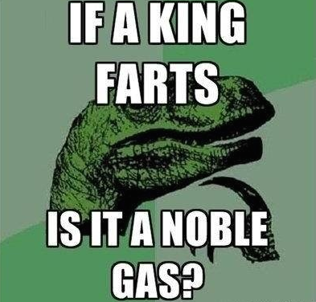
Compounds, mixtures, molecules and elements
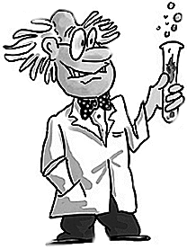
- Which of the following correctly defines a compound?

- Two atoms of one element that are chemically bonded
- Two or more atoms of different elements that are chemically bonded
- A mixture of two or more substances
- Two elements that are not chemically bonded

- Provide four examples of common compounds:

- All compounds are molecules, but not all molecules are compounds. True or false. Explain you reasoning:

- Which of the following lists contain compounds only?

- H₂0, N₂, Ar, CH₄
- HCl, NaBO₃, O₂, CaO
- NaHCO₃, CH₄, H₂O
- O₂, N₂, H₂

- Describe the difference between an atom and a molecule?

- In the box below draw an atom and a molecule. Ensure that you label your drawing.

- Examine the four boxes below. Each circle represents an atom and the different shading pattern represents different types of atoms.

A | B | C | D

Which of the boxes contains the following*:

- Individual atoms of elements only _____________________
- Chemical compounds only _____________________
- Some molecules that are not compounds _____________________
- A mixture of compounds and atoms _____________________
- A mixture of molecules and atoms _____________________

*Note: it is possible that none of the boxes contain the requested item – if this is the case then write ‘none’. It is also possible that more than one box may contain the requested item.

- Which of the following boxes represent a mixture?
(circle the correct box or boxes)

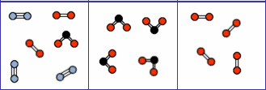

Justify your choice (what is it about the box you selected that makes you think it is a mixture?).

- Write the following statements into the correct circle below:

Can only be separated chemically Not chemically combined
Can be separated physically Combine in set proportions
Combine chemically forming molecules Can combine in any proportion

Compounds | Mixtures

Chemical reactions

What are the signs of a chemical change?

What causes rust?

How are chemical reactions represented?
Chemical changes are changes in which new substances with different properties and chemical compositions are formed and are therefore usually not easily reversed.

A chemical reaction looks like the word equation below:

Reactants Products

What is a Reactant?

What is a Product?

What is a Chemical reaction?

Why do we use word equations?

Why do we use formula equations?

Look at the following chemical formula below and answer the following questions;

2H₂ ₊O₂ 2H₂O

  - What does the large number in front of the 2H₂ tell you?

  - What does the number after the 2H₂ tell you?

  - How many Hydrogen and Oxygen MOLECULES are there before and after the chemical reaction?

  - How many Hydrogen and Oxygen ATOMS are there before and after the chemical reaction?

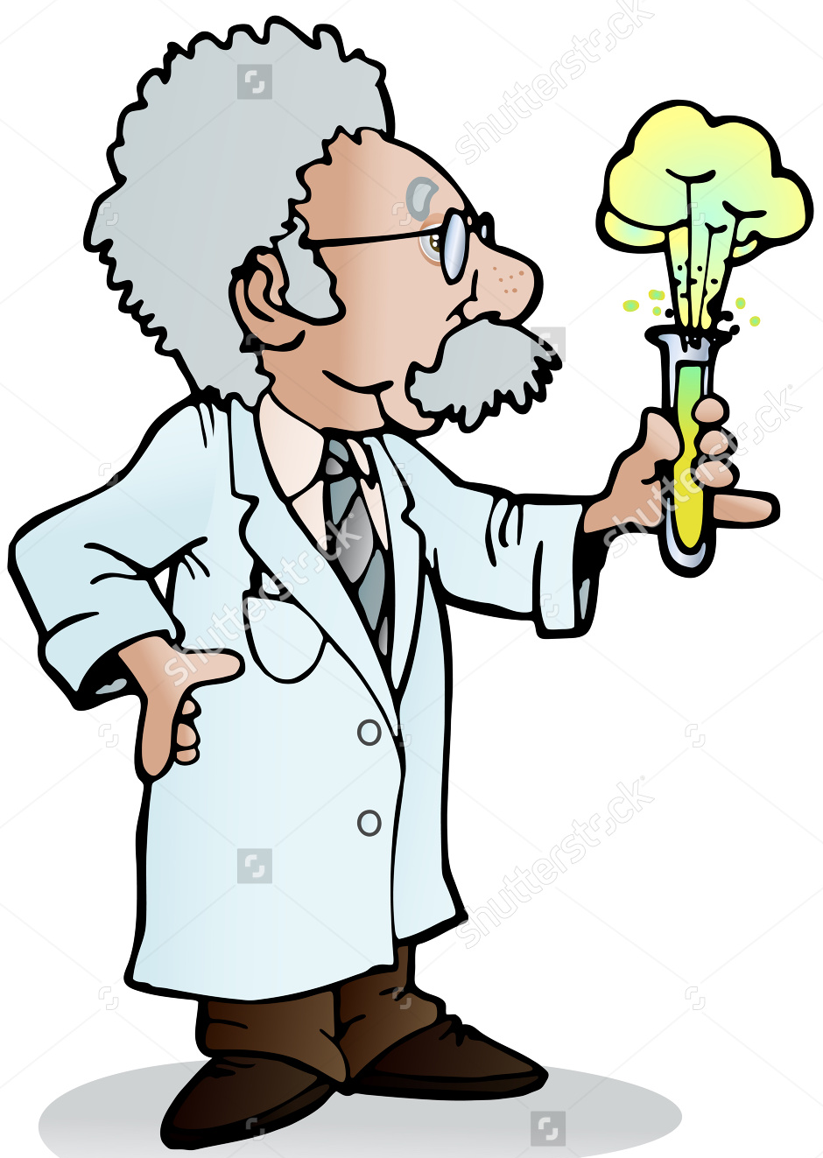
What do the following symbols mean?
- (aq) - ______________________________________
- (s) -________________________________________
- (g) -________________________________________
- (l) -_________________________________________

Answer the following questions about chemical reactions.

1. When a sodium chloride (NaCl) solution is mixed with a silver nitrate (AgNO₃) solution, white silver chloride (AgCl) is produced, leaving behind a sodium nitrate (NaNO₃) solution.

Identify the reactants.

Identify the products.

Construct a formula equation (use symbols).

Construct a word equation (use names).

2. Hydrochloric acid (HCl) reacts with silver nitrate (AgNO₃) and converts it into silver chloride (AgCl) and Nitric Acid (HNO₃)

Identify the reactants.

Identify the products.

Construct a formula equation (use symbols).

Construct a word equation (use names).

3. Zinc reacts with oxygen and converts it into zinc oxide (ZnO).

Identify the reactants.

Identify the products.

Construct a formula equation (use symbols).

Construct a word equation (use names).

4. Methane (CH₄) reacts with O₂ and converts it into H₂O and CO₂.

Identify the reactants.

Identify the products.

Construct a word equation (use names).

5. Ammonium Nitrate reacts to yield Nitrous Oxide and Water

Identify the reactants.

Identify the products.

Construct a formula equation (use symbols).

Construct a word equation (use names).

6. Magnesium + Oxygen Magnesium Oxide (MgO)

Identify the reactants.

Identify the products.

Construct a formula equation (use symbols).

7. In plants carbon dioxide reacts with water and sunlight (chlorophyll) to yield Glucose (C₆H₁₂O₆) and oxygen.

Identify the reactants.

Identify the products.

Construct a formula equation (use symbols).

Construct a word equation (use names).

8. Ethylene (C₂H₄) reacts with H₂ to yield Ethane (C₂H₆).

Identify the reactants.

Identify the products.

Construct a formula equation (use symbols).

Construct a word equation (use names).

9. Cu + S copper sulphide (CuS)

Identify the reactants.

Identify the products.

Construct a word equation (use names).

10. Fe_{(s)} + copper sulphate (CuSO₄)_{(aq)} iron sulphate (FeSO₄)_{(aq)} +Cu_{(s)}

Identify the reactants.

Identify the products.

Construct a word equation (use names).

11. Nitrogen + Oxygen Nitric Oxide (NO)

Identify the reactants.

Identify the products.

Construct a formula equation (use symbols).

12. silver nitrate (3AgNO₃) _{(aq)} + Al_{(s)} aluminium nitrate (Al(NO₃)₃)_{(aq)} + 3Ag _{(s)}

Identify the reactants.

Identify the products.

Construct a word equation (use names).

End of revision booklet

