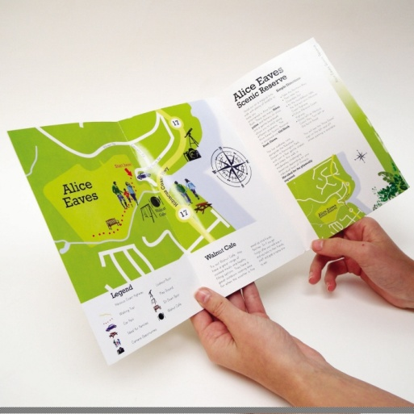
Year 9
Outdoor Rec & Leisure
Bushwalking
Assessment Task 2016

Task:
In teams of two (2) assigned by the teacher, you are to create a class presentation, advertising one of the following bushwalks from the local areas surrounding Swan CC. Your presentation time should be between 5 and 6 minutes)
Available Bushwalking Trails
Guildford Heritage Walk Trail | John George Walk Trail | Whiteman Park  (The Wununga Trail)
Bells Rapid Walk Trail | Whiteman Park  (The Goo Loorto Trail) | John Forrest National Park (Eagle View Trail)
Wandoo Heights Walk Trail | Whiteman Park  (The Werillyiup Trail) | John Forrest National Park  (Railway Reserve Heritage Trail)
Walyunga National Park  (Syd’s Rapids Walk Trail) | Walyunga National Park (Aboriginal Heritage Walk Trail) | Bibbulmun Track  (Section 1: The Darling Range)

Your presentation must include the following information:
- The name and location of the walk
- A map with the walk highlighted on it (including the street address of the starting point)
- Information about the walk: (Bonus marks: quality short video of the walk)
- Distance - Difficulty - Expected time to complete
- Information about the parkland/national park that the walk is in:
- Facilities such as toilets, barbeques, car parking, rubbish bins etc...
- Nature Information
- Types of trees, plants and animals typically found
- Specific safety tips for walking this trail.
- Specific equipment required for the walk (this is linked to the level of difficulty)
- The closest emergency service (hospital) to the walk
- “Leave No Trace” Principle Section
You will be assigned one of the seven (7) “Leave No Trace” principles.
- You will need to explain why you think is important and the negative consequences there might be if people chose to not follow that principle.
- BE PREPARED TO ANSWER QUESTIONS REGARDING YOUR PRESENTATION!
Helpful Tips
Suggested websites:
www.experienceperth.com www.tourism.wa.gov.au http://www.lnt.org.au/
www.swanvalley.com.au www.walkgps.com
Suggested software: Microsoft PowerPoint or similar
Marking Key:
- The name and location of the walk on the front page | /1
- A map with the walk highlighted on it  (including the street address of the starting point) | /2
- Information about the walk:  - Distance - Difficulty - Expected time to complete | /3
(Up to 3 bonus marks for a quality short video of the walk) | /3
- Information about the parkland/national park that the walk is in:  Facilities such as toilets, barbeques, car parking, rubbish bins etc...  Very Basic – 1 to High Quality - 3 | /3
- Nature Information  Types of trees, plants and animals typically found.  Very Basic – 1 to High Quality - 3 | /3
- Specific safety tips for walking this trail  Inappropriate – 0 Appropriate – 2 | /2
- Specific equipment required for the walk  Inappropriate – 0 Appropriate – 1 | /1
- The closest emergency service (hospital) to the walk | /1
- “Leave No Trace” Principle Section  Poor Explanation – 1 Moderate Explanation – 2 Good Explanation - 3 | /3
- Inside the appropriate time frame | /1
- Answers appropriate questions clearly and intelligently | /2
 | Total: /22
Teachers Comment:

