**Year 9 Science**

**Body Systems Revision Booklet**



**Name: __________________________________________**

**Day of Topic Test: ________________________________**

**The Nervous System**

**Revision Booklet**

1) Label the parts of the neuron below:

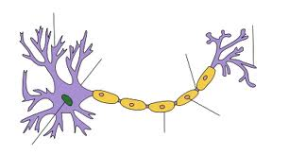

2) What are the two parts of the nervous system?

* ___________________________________________________________________________
* ___________________________________________________________________________

3) What are the main functions of the following parts of the brain:

a. Cerebrum: ___________________________________________________________________________

______________________________________________________________________________________________________________________________________________________

b. Cerebellum: ___________________________________________________________________________

______________________________________________________________________________________________________________________________________________________

c. Medulla: ___________________________________________________________________________

______________________________________________________________________________________________________________________________________________________

d. Colour and label these three structures on the diagram below.

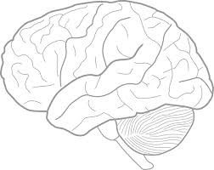

4) What makes up the different types of matter in the Central Nervous System?

White matter: ____________________________________________________________________________

Grey matter: ______________________________________________________________________________

5) Go to the following link and watch the movie. Answer the questions below as you go. <http://www.bbc.co.uk/schools/gcsebitesize/science/aqa/nervesandhormones/thenervoussystemact.shtml>

a. Fill in the gaps:

The nervous system allows the body to respond to changes in the ___________________________________________. This process is usually co-ordinated by the _________________________. The Central Nervous System consists of the brain and the ________________________ ________________________. Receptors are specialised cells that detect changes in the environment (or ____________________________________) and turn them into electrical impulses. When a receptor is stimulated, it sends a signal along the nerve cells (or _______________________________) to the brain. The brain then co-ordinates the response. Receptors are often located in __________________________ ______________________________________.

b. Fill in the table to outline what the receptors in each sense organ detects. The first one has been done for you:

|  |  |
| --- | --- |
| **Sense Organ** | **Function of receptors (what they are sensitive to)** |
| Ear |  |
| Eyes |  |
| Skin |  |
| Nose |  |
| Tongue |  |

c. What is an effector?

__________________________________________________________________________________

____________________________________________________________________________________________________________________________________________________________________

d. What are the three types of neurons?

1. _______________________________________________________________________________

2. _______________________________________________________________________________

3. _______________________________________________________________________________

e. Draw a line matching the Neuron type to its function:

|  |  |
| --- | --- |
| Sensory Neurones | Carry signals from the sensory to motor neurons. |
| Motor Neurones | Carry signals from receptors to the spinal cord and brain |
| Interneurons Neurones | Carry signals to the parts of the body that move |

f. True or False?

1. Reflex actions involve the brain.
2. A pupil constricting in bright light is an example of a reflex action.

6) The ear has two functions. One is to hear sound and the other to help us keep our balance. Explain how our ears help us to balance.

__________________________________________________________________________________

__________________________________________________________________________________

__________________________________________________________________________________

__________________________________________________________________________________

7) What can be a cause of colour blindness? _____________________________________________

____________________________________________________________________________________________________________________________________________________________________

8) Write out in four steps the pathway light travels from when it enters the eye to when it reaches the brain.

1. ___________________________________________________________________________

___________________________________________________________________________

2. ___________________________________________________________________________

___________________________________________________________________________

3.

______________________________________________________________________________________________________________________________________________________

4. ______________________________________________________________________________________________________________________________________________________

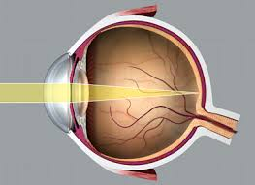

9) Trey has given Claudia his cold and she now has a blocked nose. She was very upset at him as she ate some sardines (her favourite food) but could no longer taste them. Explain why you think this happened.

__________________________________________________________________________________

__________________________________________________________________________________

__________________________________________________________________________________

__________________________________________________________________________________

_________________________________________________________________________________

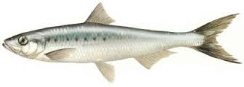

Nervous System Worksheet

1. List three ways the human body receives information other than your eyes.
2. Neurons are specialized cells that make up the nervous system, what is their function?

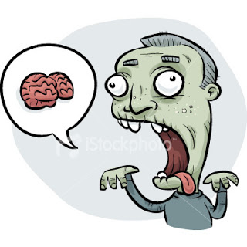

1. When you touch something hot, what type of neuron receives the message?
2. Where is that message sent next?
3. Once that message is received and interpreted, the body sends a message to the motor neurons causing what?

__________________________________________________________________________________

__________________________________________________________________________________

__________________________________________________________________________________

1. What is the difference between the central nervous system and the peripheral nervous system?

__________________________________________________________________________________

__________________________________________________________________________________

__________________________________________________________________________________

1. List and explain these two parts of the nervous system.

Brain _____________________________________________________________________________________________________________________________________________________________________________________________________________________________________________

Spinal cord _____________________________________________________________________________________________________________________________________________________________________________________________________________________________________________

1. If someone is in a car accident and not wearing their seatbelt, what kind of damages could happen to their nervous system?

__________________________________________________________________________________

__________________________________________________________________________________

__________________________________________________________________________________

__________________________________________________________________________________

1. What are three different ways, other than wearing your seatbelt in a car, you can take safety precautions to protect your nervous system from injury?
2. ___________________________________________________________________________
3. ___________________________________________________________________________
4. ___________________________________________________________________________
5. List the functions of each part of the brain

Cerebrum –

Cerebellum –

Brain Stem –

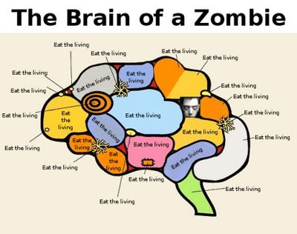

1. What structures make up the Central Nervous System (CNS)?
2. ___________________________
3. ___________________________
4. Signals are conducted by nerves, which are bundles of _______________ wrapped in connective tissue.
5. Sensory and motor neurons make up the ______**________________** nervous system.
6. The structural and functional unit of the nervous system is the _____________________.
7. Draw and label the main parts of a sensory, motor or interneuron.
8. Draw a diagram showing the central and peripheral nervous systems (use different colours/pens):

**The Endocrine System**

**Revision Workbook**

1. Use the words below to fill In the blanks.

|  |  |  |  |  |
| --- | --- | --- | --- | --- |
| hormones | internal | target | glands | cells |
| nervous | bloodstream | endocrine | throughout | optimal |

Coordination of body parts is achieved by the joint efforts of the _____________________________ and _____________________________ systems. This coordination is important for homeostasis – maintaining our body’s _________________ environment at _________________ levels.

The endocrine system is made up of ___________________ that secrete ___________________ into the __________________________This means that they are spread __________________________ the body. Only specific body cells (_____________ _________) can respond to the shape of any one hormone.

1. Match the endocrine glands with their correct locations in the body and then label them on the diagram. Add labels for the thymus and pineal gland.

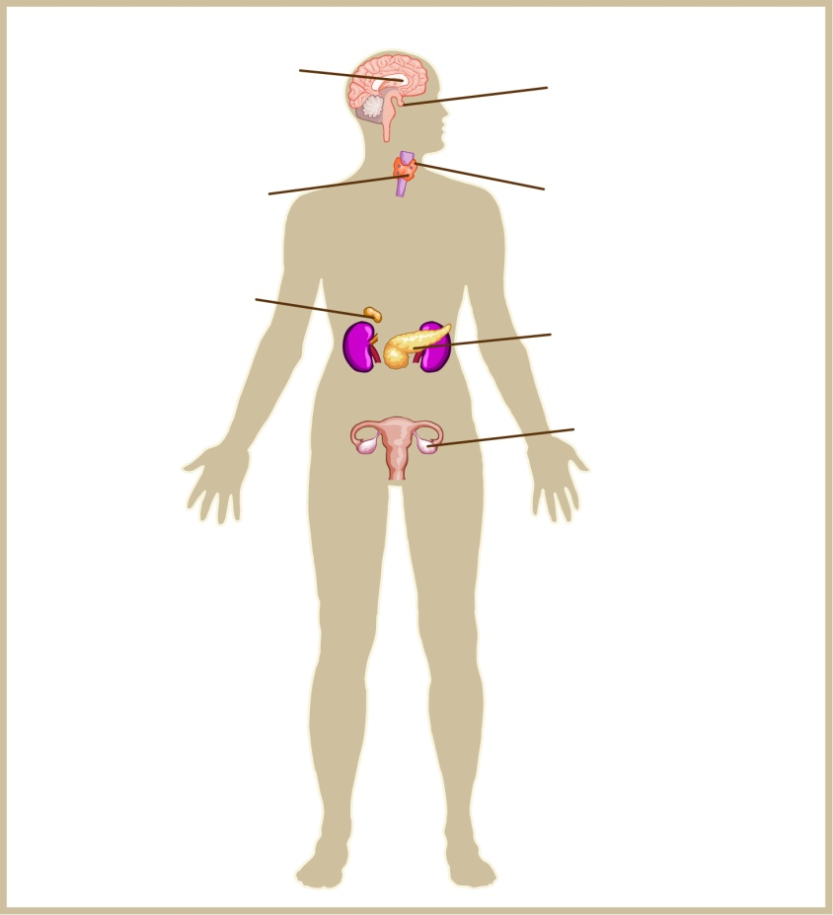

### Endocrine glands Locations on the body

1. pituitary a) on the larynx in the throat
2. parathyroids b) in the lower abdomen of the female body
3. thyroid c) below the liver in the upper abdomen
4. adrenal d) at the base of the brain – anterior and posterior lobes
5. pancreas e) within the brain
6. ovaries (in females) f) held within scrotum
7. testes g) embedded in the thyroid gland
8. hypothalamus h) on the top of the kidneys
9. What are hormones?

______________________________________________________________________________

______________________________________________________________________________

1. What gland controls the rest of the endocrine system? _________________________
2. What is the part of the endocrine system that links the endocrine and nervous systems?

_______________________________________________________________________________

1. Define Homeostasis:

______________________________________________________________________________

______________________________________________________________________________

1. Explain how the endocrine system aids humans in maintaining homeostasis.

______________________________________________________________________________

______________________________________________________________________________

______________________________________________________________________________

______________________________________________________________________________

1. Describe the relationship that exists between the hypothalamus and pituitary gland

______________________________________________________________________________________________________________________________________________________________________________________________________________________________________________________________________________________________________________________________________________________________________________________________________________________________________________________________________________________________________________________________________________________________

1. Describe the role the circulatory system plays in the functioning of the endocrine system.

_______________________________________________________________________________

_______________________________________________________________________________

_______________________________________________________________________________

_______________________________________________________________________________

1. 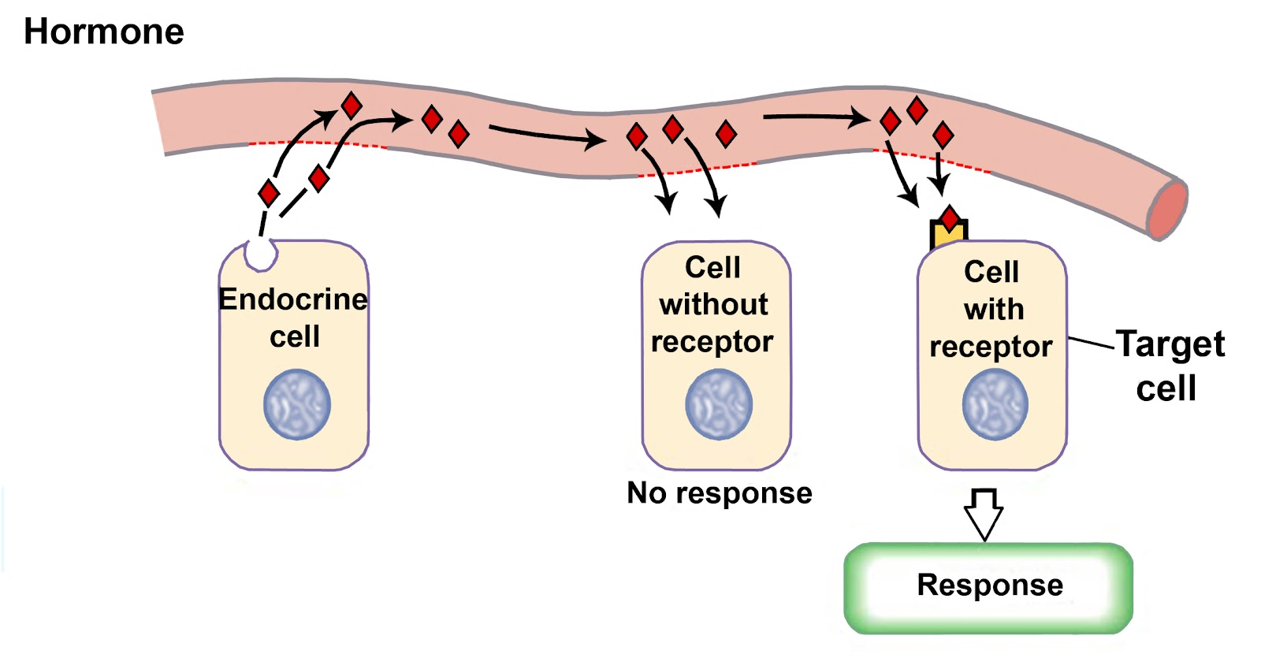Hormones are very specific and will only bind to certain cells. Outline the pathway a hormone takes from when it leaves the endocrine gland to when it binds to its target cell. Use the diagram below to help you.
2. Complete the table below depicting the different hormones and their glands

|  |  |  |  |
| --- | --- | --- | --- |
| **Endocrine Gland** | **Hormone Secreted** | **Target Organ** | **Effect on Target Organ** |
| *Hypothalamus* | Neurohormones |  |  |
| *Pituitary gland* | Thyroid Stimulating Hormone |  |  |
| Growth Hormone |  |  |
| *Thyroid* |  |  |  |
| *Parathyroid* |  |  |  |
| *Pancreas* |  |  |  |
|  |  |  |
| *Adrenal Gland* |  |  |  |
|  |  |  |
| *Gonads (Testes)* |  |  |  |
| *Gonads (Ovaries)* |  |  |  |
| *Pineal Gland* |  |  |  |

1. Comparison of the Nervous and Endocrine Systems

|  |  |  |
| --- | --- | --- |
| **Function** | **Nervous** | **Endocrine** |
| Speed (reaction time) |  |  |
| Duration of response |  |  |
| Specificity |  |  |

1. What is the overall function of the endocrine system?

_______________________________________________________________________________

_______________________________________________________________________________

1. With what other systems does the endocrine system interact?

______________________________________________________________________________

______________________________________________________________________________

1. Define the terms below:
2. Insulin: ___________________________________________________________________________

___________________________________________________________________________

1. Glucagon: ___________________________________________________________________________

___________________________________________________________________________

1. Glycogen:

___________________________________________________________________________

___________________________________________________________________________

1. Draw out a flow diagram outlining how blood sugar levels are controlled in your body.
2. Draw out a flow diagram outlining how temperature is controlled in your body.

**EXTENSION / ADVANCED**

1. In response to a stressful stimulus, the adrenal gland increases secretion of
2. Throxine
3. Glucagon
4. Adrenaline
5. Growth hormone
6. Which of the following symptoms could indicate hypothyroidism?
7. Inceased metabolism
8. fatigue
9. protruding eyeballs
10. excessive sweating
11. Thyroxine is:
12. Made and released by the pituitary gland
13. Released when there is a really high metabolic rate
14. Released only when indicated to by the binding of Thyroid Stimulating Hormone
15. A hormone that causes you to grow.

**The NEXT question refers to the image below:**

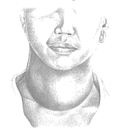

1. This person
2. Would have a problem with their adrenal gland
3. Would have a very slow metabolic rate
4. May be suffering from a tumour in their pineal gland
5. Has too much glucagon being released
6. A person with diabetes would likely have:
7. An excessive amount of insulin being secreted
8. Too little insulin being released
9. A problem with their adrenal gland
10. Reduced amount of adrenalin in their bloodstream
11. Many homeostatic mechanisms are regulated by the hypothalamus.

The diagram below shows the relationship between the hypothalamus and the pituitary gland.



1. Describe the process leading to the secretion of hormones from the pituitary gland into the bloodstream. (3 marks)

________________________________________________________________________

________________________________________________________________________

________________________________________________________________________

1. The posterior lobe of the pituitary gland is not considered an endocrine gland. Hypothesise why this might be the case. HINT: think about what endocrine glands do.

(2 marks)

________________________________________________________________________

________________________________________________________________________

________________________________________________________________________

1. Riley underwent a series of medical tests and was found to have low calcium levels in his blood due to a hormonal imbalance.
2. Which hormone would normally increase in the blood when calcium levels are low?

(1 mark)

________________________________________________________________________

1. For the hormone described in part (a), there are several effectors in the body, one of which is bone. Predict what would happen to cause the increase in blood calcium levels when the parathyroid hormone binds to the bone. (2 marks)

________________________________________________________________________

1. George loved hiking and would often go walking with very little preparation. One day whilst out in the forest, a storm blew up and it started to rain. He slipped on the muddy track and fell down a ravine, badly injuring his leg. Unable to move, and dressed only in shorts and a T-shirt, he was trapped there overnight until he was found by hikers the next day. Briefly discuss the mechanisms of heat loss that would have contributed to his hypothermia. (3 marks)

_____________________________________________________________________________________________________________________________________________________________________________________________________________________________________________________________________________________________________________________________________________________________________________

1. The graph below shows blood glucose concentrations for two people over a period of 8 hours. Two and a half hours into the test, both people consumed a quantity of liquid glucose.

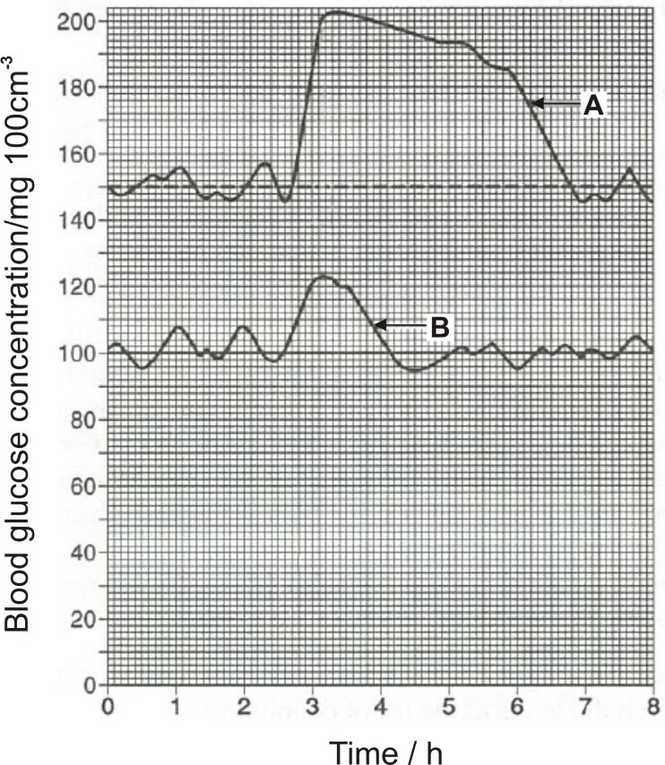

1. Which graph (A or B) indicates a person with diabetes mellitus? Give one reason for your choice. (2 marks)

_________________________________________________________________________________________________________________________________________________________________________________________________________

1. By what mechanism are blood glucose levels normally maintained? (1 mark)

______________________________________________________________________________________________________________________________________

1. Naomi has just eaten a large bag of fairy floss. Fill out the negative feedback loop below to outline how her body will go about restoring homeostasis to her blood sugar levels.

(6 marks)

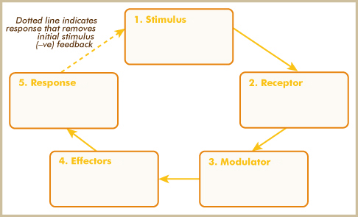

**Immune System**

**Revision Workbook**

1. A **pathogen** is_____________________________________________________________________________________________________________________________________________________
2. A **disease** is_____________________________________________________________________________________________________________________________________________________
3. What is the difference between an **infectious** and **contagious** disease?

______________________________________________________________________________________________________________________________________________________

1. Complete the pathogen table below:

|  |  |  |
| --- | --- | --- |
| **Pathogen** | **Information / Detail** | **Example** |
|  |  |  |
|  |  |  |
|  |  |  |
|  |  |  |

1. The body has ______ lines of defense, what are they called:
   1. _______________________________________________________
   2. _______________________________________________________
   3. _______________________________________________________
2. What is the body’s **first line of defense**? Label the diagram with each component of the line of defense, and explain their mechanism.

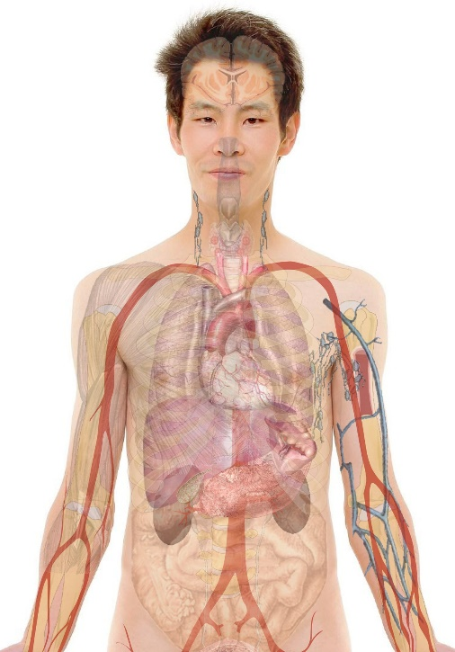

1. The body has a **second line of defense**, which can be divided into two sections, what are those sections?
   1. ____________________________________________________________________
   2. ____________________________________________________________________
2. A patient is feeling sick and has a **fever**, explain what is happening within the body.

_____________________________________________________________________________________________________________________________________________________________________________________________________________________________________________

1. A student has fallen over and injured their knee. The wound is **inflamed** and blood is starting to **clot**. Explain what is happening within the body.

_____________________________________________________________________________________________________________________________________________________________________________________________________________________________________________

1. What is the purpose of a white blood cell?

_____________________________________________________________________________________________________________________________________________________________________________________________________________________________________________

1. Compare **macrophages** and **neutrophils** in the table below:

|  |  |
| --- | --- |
| Macrophage | Neutrophil |
|  |  |

1. What is **phagocytosis**? Label the diagram and explain the process below.



____________________________________________________________________________________________________________________________________________________________________________________________________________________________________________________________________________________________________________________________

1. What is the purpose of antibodies? Draw a diagram and label to help explain.
2. What is the **third line of defense**? What makes this line of defense different to the other lines?

____________________________________________________________________________________________________________________________________________________________________________________________________________________________________________________________________________________________________________________________

1. Compare B-cells and T-cells and their purpose in the **third line of defense**.

|  |  |
| --- | --- |
| **B-Cells** | **T-Cells** |
|  |  |

1. What is the **cell** that ensures the body will be protected from a specific infection in the future?

___________________________________________________________________________

1. Sometimes the immune system can go wrong, provided two (2) examples of this and outline what happens in the body.

__________________________________________________________________________________________________________________________________________________________________________________________________________________________________________________________________________________________________________________________________________________________________________________________________________________________________________________________________

1. What is a vaccination and how do they work? Discuss the dangers of not vaccinating in relation to “herd immunity”.

_____________________________________________________________________________________________________________________________________________________________________________________________________________________________________________________________________________________________________________________________________________________________________________________________________________________________________________________________________________________________________________________________________________

