Electricity 1 Name: ____________________________

What is Electricity?
- A form of energy caused by the movement of _________________________.
- Atoms are made of _________________________ (+),_________________________ and _________________________ (-)
- Electrons can be knocked off one atom and _________________________ to the next.

- Draw a diagram of a fluorine atom (P=9, N=10, E=9), adding the charges for each particle on the diagram.

2) What would happen to the overall charge of an atom if it were to:

a. lose electrons: _________________________________________________________________
b. gain electrons: _________________________________________________________________
c. why would this happen? ______________________________________________________
__________________________________________________________________________________
d. Two of the same charges will repel/attract each other whilst two different charges will repel/attract each other

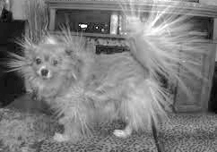
Static Electricity:
- Is the build-up of electrical _____________________ on a ________________
- Usually due to one surface rubbing against another, rubbing the electrons off one (_____________________ ______ _____________________) onto the other (_____________________ ______ _____________________)
- The charge usually ___________________ away after some time into the _____________________
- If the build-up continues, the electrons may _____________________ _____________________ ___ _____________ from the negative to the positive surface
- This converts the energy into ___________________, ___________________, ___________________ and _____________________ (basically a mini lightning bolt).
- In your own words, summarise what static electricity is:

_____________________________________________________________________________________________
_____________________________________________________________________________________________
_____________________________________________________________________________________________
_____________________________________________________________________________________________

Current Electricity:

- The electricity you get from a _____________________ or _____________________ is _____________ static electricity
- It is electrons _____________________ _____________________ _____ _____________. This is called a _____________________
- These moving electrons have energy that is ___________________________ into other forms as they go through ____________________________ (e.g. light globes)

- List four forms of useful energy that current electricity could be transformed into:

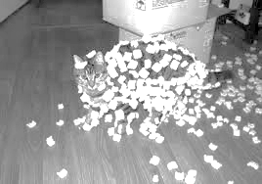
i.
ii.
iii.
iv.

- In your own words, compare and contrast static electricity vs current electricity.
_________________________________________________________________________________________________________________________________________________________________________________________________________________________________________________________________________________________________________________________________________________________________________________________________________________________________________

