**Year 11 Christian Living**

***Hinduism***

***‘the way of release’***

*Based on: ‘A spectator’s guide to world religions” By: John Dickson*

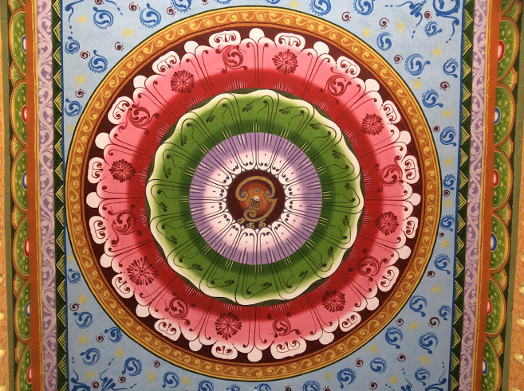

***Introduction:***

“As the title makes clear, this book is not written for religious devotees but for spectators, those with a simple curiosity about Hinduism, Buddhism, Judaism, Christianity and Islam. In our multicultural society such curiosity is a worthy thing. I enjoy the culinary benefits of multiculturalism—Pad Thai is my favourite dish. But with this enjoyment comes a certain obligation, I believe, to understand a little about how our new neighbours view the world. Nothing provides a better window into a culture’s views than its religion. When you sit in your local Thai restaurant, wouldn’t it be nice to know why there is a little shrine on the wall? This is not simply a decoration. Nor is it there to appear ‘authentically Asian’. If you happen to ask, you’ll probably find that the shrine represents an important part your Buddhist restauranteur’s life. If nothing else, by the end of this book you will be able to eat out at your local Indian, Thai, Chinese, Persian and Kosher restaurants and explain to your friends what makes Buddhism different from Hinduism, and how Islam responded to the Jewish and Christian communities of its time. Hopefully, there will be some additional spin-offs as well.

Of course, religion is far more than a topic of dinner party conversation. It is fair to say that nothing has influenced the world—for good and ill—more than the world religions. Much of the world’s art and music grew out of religious devotion. Music historians will often tell you how rock grew out of gospel, and how classical grew out of medieval church music. The social laws of most societies were shaped decisively by religion. In recent times, academic ethicists have sought to distance morality from religion, insisting that one doesn’t need a big spiritual truth in order to find a solid intellectual basis for ethical living—that’s a debate for another book. However, there’s no denying the simple social observation that throughout the history of the world religion has played a large part in organising our views of right and wrong. The big questions addressed by the world religions are truly universal: Who are we? What is our worth? How should we live? Are we alone? Because of this, I’ve often described the religious inclinations of humanity as common sense. My atheist friends don’t like this very much but I think it is nonetheless true. The human fascination with religion is like the human interest in music, art and learning. They are found all throughout the world. They are, if you like, among the few universally shared pursuits of Homo sapiens throughout time. I can’t speak authoritatively for art or music but in the case of religion it is no exaggeration to say that every single society about which anthropologists and historians know anything significant has made religion a central part of its cultural life. In this way, religious questions are common sense—they are ‘common’ to our humanity.”

“I am more than ever convinced that each of the world’s religions is a ‘work of art’, worthy of a public showing in the best light. At the same time, I am also more than ever confident of the unique character of the Christian faith. I can think of no better way to help readers see that quality than to turn all the gallery lights on full and let you view the whole collection for yourself.” – John Dickson

***Preconceptions Quiz***

1. ***What do you think Hinduism is about?***
2. ***Who do Hindu’s worship and how do they worship?***



1. ***What does this symbol mean in Jainism, an offshoot of Hinduism?***
2. ***What is karma?***
3. ***What is a caste?***

***History:***

* The term *Hindu* was taken from a location called the ‘Indus Valley’.
* British writers used the word to describe the range of practices and rituals they observed.
* It is the oldest of the 5 religions we are looking at.

***Ancient Writings:***

* The main Hindu writings fall into three main categories:

***1. The Vedas - wisdom***

***2. Key Veda Teachings***

***3. Student Task***

**Look up the following 5 Hindu gods that are found in the Vedas and complete the following.**

* **Look up each god on Google and observe one of the images.**
* **Based on the picture, try to determine what each god’s power/purpose is.**
* **Finally, research the god’s actual purpose and note it down.**

***Discussion:*** Why do you think that Hinduism has such a diversity of gods?

***4. The Upanishads – sitting near***

***Background:***

* The Upanishads were constructed by Indian gurus who reflected on the content of their religion, and sought to make sense of the world in light of it.
* The Upanishads are considered by many Hindus as the real sacred writings of Hinduism.

***5. Key Upanishad Teachings***

**Complete this section as a summary to the Expert Groups Activity found on the next page.**

* **Draw arrows to show the relationship between the different terms/ideas.**
* **Label as appropriate using the terms from your expert groups.**

**Moksha** – “a spark returning to the flame”

***6. Expert Groups Activity***

**In groups of four, you will each choose to research one of the teachings.**

* **First, leave your main group and join the expert group that corresponds to your topic.**
* **Second, read and discuss the teaching with your fellow experts.**
* **Third, note down in dot points 4-5 key thoughts that summarise the teaching in your triangle.**
* **Fourth, return to your main group and share your findings with the group.**
* **Finally, write down the dot points that your group members share about the other terms.**

1. ***Excerpts from the Upanishads***

Keep in mind that this is a translation that is very loose, non-literal, and poeticized.  Also note that where the translator says “God,” the Hindu term is actually “*Brahman,*” which “is the unchanging, infinite, immanent, and transcendent reality which is the Divine Ground of all matter, energy, time, space, being, and everything beyond in this Universe.” Depending on the particular philosophic school of Hinduism, Brahman might be a personal god, but might also be an impersonal force, or something that transcends the concepts of personal and impersonal.

**Brihadaranyaka Upanishad 4:4.3-7**

*When a caterpillar has come to the end of a blade of grass, it reaches out to another blade, and draws itself over to it. In the same way the soul, having coming to the end of one life, reaches out to another body, and draws itself over to it.*

*A goldsmith takes an old ornament and fashions it into a new and more beautiful one. In the same way the soul. as it leaves one body, looks for a new body which is more beautiful.*

*The soul is divine. But through ignorance people often identify the soul with the mind, the senses and the emotions. Some people even identify the soul with the elements of earth, water, air, space and fire.*

*As people act, so they become. If their actions are good, they become good; if their actions are bad, they become bad. Good deeds purify those who perform them; bad deeds pollute those who perform them.*

*Thus we may say that we are what we desire. Our will springs from our desires; our actions spring from our will; and what we are, springs from our actions. We may conclude, therefore, that the state of our desires at the time of death determines our next life; we return to earth in order to satisfy those desires.*

*Consider those who in the course of many lives on earth have become free from desire. By this we mean that all their desires have found fulfillment within the soul itself. They do not die as others do. Since they understand God, they merge with God.*

*'When all the desires clinging to the heart fall away, the mortal becomes immortal. When all the knots of desire strangling the heart are loosened, liberation occurs.*

*As the snake discards its skin, leaving it lifeless on an anthill, so the soul free from desire discards the body, and unites with God who is eternal life and boundless light.*

Reference: http://www.ucs.louisiana.edu/~ras2777/spirituality/reincarnation.htm

**A picture containing clipart

Description generated with very high confidence**

***8. Smriti***

***Background:***

* A collection of sacred literature containing two important poems.
* The Song of the Lord (Bhagavad-gita) is a story that is regarded by many as the most treasured of all Hindu scriptures.

**Two Main Characters**

* Prince Arjuna and his advisor Krishna. Krishna turns out to be an incarnation of the god Vishnu

**Story Plot**

* Prince Arjuna is getting ready to slay the opposing armies, he wonders whether he should lay down his weapons to avoid shedding blood. Krishna enters saying - ‘he needs to fulfil his duty as a warrior prince’. This introduces the ‘Four Castes’ of people in Hinduism.

**Discuss**: If a person does a good deed that is outside their caste, does this benefit them?

***9. Research Activity***

* Research the three individuals below.
* Describe what they thought of the caste system.
* Explain what they did about it.

***10. Putting it all together***

*‘Thou art that’*

‘*Atman is Brahman’*

The ultimate reality is called ‘Brahman’ - ***The*** ***ultimate end of Hinduism is realising our unity with Brahman.***

Realising that in the depths of our soul (Atman), we are all one, like a single, under–sea continent. Even though an island appears on the surface, to be separate, it is in fact a part of something bigger. That is what we really all are; Brahman - infinite and absolute perfection.

***11. The 3 Yogas***

* ‘Yogas’ – oneness with Brahman
* By succeeding in one of these paths, one can escape birth and re-birth and obtain Moksha.

***Discuss:*** Why is it ok for some Hindu’s to fight wars and it is not okay for others?

***12. Two popular gods***

A group of people posing for the camera

Description generated with high confidence***Vishnu***

* (Vaishnavism) – Worshipers typically take a blend of their favourite stories and incarnations of Vishnu. Most commonly Mahabharata.
* Vishnu is thought to have had 10 incarnations, or Avatars. The two most popular are Rava and Krishna (mentioned earlier).
* Vishnu is thought to embody the preserving qualities of ‘Brahman’ - Turns Brahman into a person.

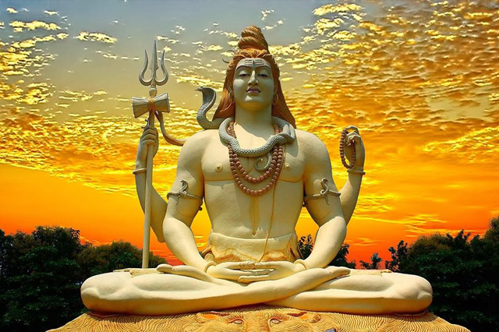***Siva***

* (Saivism) – features in the great epics of the ‘remembered writings’ (Smriti).
* Also thought to embody characteristics of Brahman. Whereas Vishnu is the friend and preserver of humanity, Siva is the multi-faceted master over nature and human beings.
* Side-note – teachers from a branch of Saivism during the 1200s AD developed a particular form of yoga (hatha-yoga) involving difficult breathing and body exercises. This was thought to bring ‘oneness’ with the divine. Sound familiar?

***13. Summary Worksheet***

**Vedas**:

1. How do you think a persons life would be affected by their belief in polytheism

**Upanishads**:

1. What is the interaction between Brahman and polytheism?
2. What do you feel the ultimate goal of being a human is?
3. 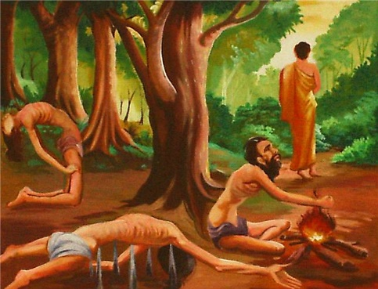Compare your ultimate goal and the ultimate goal in Hinduism (*moksha*). How are they similar, how are they different?

**Smriti**:

1. How do you think dharma and the caste system is *beneficial* to a society?
2. How do you think dharma and the caste system is *detrimental* to a society?
3. Which path (*yoga*) do you find the most appealing and why?

**Overall**:

1. From memory, draw the interaction between Brahman, Karma, Samsara, Moksha and Atman.
2. What do you see is the ‘good news’ of Hinduism?

**Extension:**

1. Look up the word ‘asceticism’ and write down the definition in your glossery of terms.
2. How does this explain certain practices in Hinduism?

***14. Big Picture Task***

***On your own mind-map, add the following information and then respond to each question.***

***Glossary of Terms:***

***Atman –*** *The Hindu soul.*

***Bhakti yoga –*** *Hindu path of devotion.*

***Brahman –*** *Hindu concept – the ultimate and only reality of the universe.*

***Dharma –*** *Hindu duty.*

***Jnana yoga –*** *Hindu path of knowledge.*

***Karma –*** *actions that determine future existence.*

***Karma yoga –*** *Hindu path of duties.*

***Moksha –*** *Hindu escape into ultimate reality.*

***Samsara –*** *Hindu notion of entrapment in birth, death and rebirth.*

***Yoga –*** *Oneness. Associated with a path that leads to oneness with Brahman.*

***__________________ - _________________________________________________________________________________________________***

