Year 11 Christian Living

Buddhism
‘the way of enlightenment’

Based on: ‘A spectator’s guide to world religions' By: John Dickson
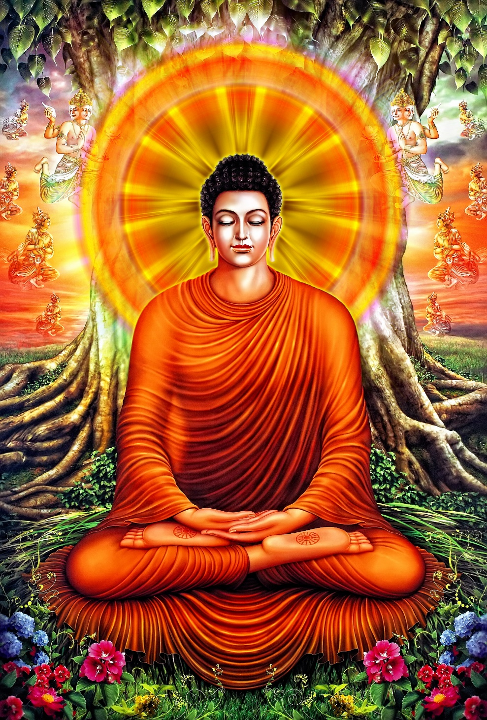

1. Student Activity: Brainstorm

What do you know about Buddhism?

2. History
- Buddhism is probably the most intellectually sophisticated of the faiths.
- It also requires the highest level of discipline
- Birthplace of the Buddha was in Lumbini, Nepal
____________________ | ____________________
Picture credit: Ploylada Sirachadapong - http://www.glittersnipe.com/2012/06/25/five-clues-that-your-thai-restaurant-is-fake/

3. How Prince Siddhartha Gautama became Buddha
“Siddhartha Gautama lived in northern India in the 6th century C.E. He was born into a Hindu family of the ruling caste. Ancient Buddhist texts record slightly different stories about his life and how he became a "Buddha" or "enlightened one." Here is the most common version.
Siddhartha was about 5 days old when his father called a group of priests together for a feast. He asked them about the infant's future. They prophesied that the infant would either become a great king or a great sage. The father preferred his son to become a great king, so he structured his son's life such that he never had to face any of the hardship or struggles of life. Why?
Because in the Hindu tradition of the time (which you can read about here), those who became holy men or sages followed a path of renunciation. At a certain point in their lives, they would renounce what was called "householder" life - a life of marriage, family, work, etc. - and go live in the forest where they spent the rest of their lives in study, meditation and other spiritual practices.
Siddhartha's father did not want his son to become one of these renouncers, so he made sure his son's life was as perfect as possible, offering everything wonderful and nothing negative or upsetting. The father made sure his son was shielded from anything that would make him want to leave the kingdom.
One day, as Siddhartha was touring a park area of the kingdom, he saw four things that changed his life. First, he saw a sick person. He had never seen a sick person before and was shocked at the sight. Next, he saw an old person, someone stooped over and suffering the effects of old age. Again, he was shocked for he'd never seen this suffering before. Then, he saw a corpse! He'd certainly never seen a dead person before, nor did he even really understand the reality of death. His father had kept him sheltered from all these things, particularly death.
Finally, he saw a sage or holy man walking up the path. The sage passed by the sick person, the old person and the corpse - and as he did so, his face and demeanor was filled with compassion, peacefulness and joy.
Siddhartha at that moment recognized for the first time the profound suffering that even the best of lives involves. He resolved to be like the sage, who in the midst of sickness, old age and death could still live a life of compassion, peacefulness and joy.
So, he returned to the palace and made plans to renounce the kingdom and his life, and to wander into the forest to seek enlightenment.
Once in the forest, Siddhartha Gautama undertook the strict ascetic practices of the Hindu forest tradition, such as extreme fasting from food and water. At one point, the stories say, he ate only 1 grain of rice and 1 drop of water a day, and became so thin that he could place his hand on his stomach and close his fingers around his backbone!
He became emaciated and weak, so much so that he couldn't meditate or do the other spiritual practices of the tradition. So, he began eating again until he regained strength and then embarked again upon the meditative path in order to achieve enlightenment.
After a great struggle within himself and the "demons" of ignorance, he finally broke through the illusions of his own mind and experienced true Reality. He achieved enlightenment and became a "buddha" - an enlightened one.” – http://www.world-religions-professor.com/siddhartha.html

4. The Enlightenment of Buddha
- First name was _________________________________________
- Born into an upper caste and enjoyed a luxurious lifestyle.
- Observed 4 different men in 4 different states.
- Sought understanding for this suffering and undertook suffering himself.
- Neither extreme led to insight so he proposed a ‘___________________________’ that were explained by 4 beliefs and 8 habits.

Question: What were the 4 conditions of the men that Siddhartha Gautama observed?

Question: Upon enlightenment, 5 colours emanated from Buddha. What does each colour mean?

Blue –

Yellow –

Red –

White –

Orange –

5. The 5 Aggregates of Attachment

Question: Summarise what Buddha’s explanation of ‘self’ is.

Application

Extension Task
Apply the 5 factors to another example like sound or touch.

6. The 4 Noble Truths
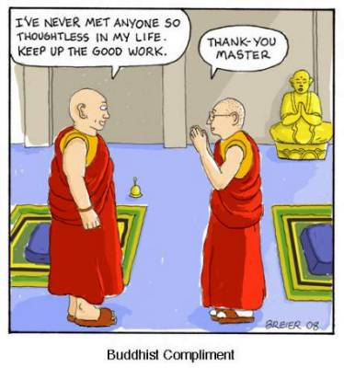
Define:
Karma –
Nirvana –

Understanding Nirvana:
Task 1: | Task 2:
Identify how those who have reached Nirvana will react to the following situations and explain why. | Research the 4 levels of Nirvana. Name them and explain what each level is.
Poverty

Personal Insults
Application:
Read the following news article excerpt and answer the question.
SANTA MONICA, California (CNN) Thursday, July 17, 2003 --An 86-year-old man who drove his mid-size Buick through a crowded farmers' market Wednesday told police he couldn't stop and may have hit the accelerator instead of the brake, Santa Monica Police Chief James T. Butts Jr. said.
Nine people were killed, including a 3-year-old girl, authorities said. The more than 54 hurt include 14 people with critical injuries, they said. Two of those critically injured are under the age of 2.
"He said that he tried to brake and he couldn't stop the vehicle," Butts said.
Police escorted the man, identified by his attorney as Russell Weller, to a local hospital where he was found to have no alcohol or psychiatric medications in his system.
Later, Weller walked out of the police station with the help of a cane and with his attorney by his side. Police released him from custody after he was interviewed by detectives. Charges could be filed at a later time, Butts said, noting that Weller is a resident of Santa Monica and does not appear to be a flight risk.
"Right now it looks as though there may be some negligence as far as his capacity to drive safely," Butts said. There was no indication that Weller intended to injure any pedestrians.
The driver's attorney, Jim Bianco, released a statement from the family late Wednesday:
"Mr. Weller and his family want to express their deepest sympathies to the victims and their families of the tragic accident earlier today. This was an unintentional and unfortunate accident. Mr. Weller is very shaken up, but his thoughts are with the victims and their families."
He declined any further statements, in light of the ongoing investigation, with which Bianco said "we are cooperating fully."
Butts said Weller drove his 1992 Buick LeSabre "at least at a moderate rate of speed" for three blocks along the market street, which was filled with pedestrians, "striking dozens of people." The car stopped only after a pedestrian was thrown into the air and landed on the windshield of the vehicle, Butts said.
As police roped off the crime scene, a child's blue stroller sat empty in the street amid bodies covered with yellow tarps.
"This is the single most horrific, devastating scene of tragedy I've ever witnessed in 30 years of law enforcement," Butts said. He added that the sight of the dead child "just broke my heart."
Crisman said he ran outside to help after the accident. There was "so much carnage," he said.
Question: What would the Buddhist faith have to offer in the way of comfort to the families of these people regarding this suffering and what they are going through?

7. Extension: The Source of Buddha’s teachings?
From where did Buddha get his philosophy? This is a very debated topic with some saying that they are derived from the Hindu Upanishads. Consider the text below and respond to the questions.
Katha Upanishad 6.1-5, 10-11, 13-16
The tree of eternity has its roots in the sky, and its branches reach down to earth. It is God; it is the immortal soul.
The whole universe comes from God; his energy burns like fire, and his power reverberates like thunder, in every part of the universe. In honor of God the sun shines, the clouds rain, and the winds blow. Death itself goes about its business in fear of God.
If you fail to see God in the present life, then after death you must take on another body; if you see God, then you will break free from the cycle of birth and death. God can be seen, like the reflection in a mirror, in a pure heart.
When the senses are calm and the mind is motionless, then your heart is pure; you have reached the highest state of consciousness, in which you are unified with God. If this state of consciousness is firm and secure, so it can never be broken, then you are free.
To calm the senses and still the mind, you must abandon the self. You must renounce 'I' and 'me' and 'mine'. You must suppress every desire that surges around the heart. You must untie every knot of attachment.
A hundred and one lights radiate from the heart. One of them shines upwards to the crown of the head. This points the way to immortality. Every other light points to death.
"A man is hit with a poisoned arrow and his friends hasten to the doctor. As the latter is about to draw the arrow out of the wound, the wounded man however cries, 'Stop! I'll not have the arrow drawn out until I know who shot it; whether a woman or a brahmin or a vaishya, his lineage, his physical description etc and so on. What would happen? The man would die before all these questions were answered. In the same way the disciple who wished for answers to all his questions about the beyond, would die before he understood the four noble truths."

Parable of Buddha
From the Majjhima Nikhaayaa text
How does the Katha Upanishad text show specific Hindu teachings?

How does the Katha Upanishad text show specific Buddhist teachings?

8. The Eightfold Path

Task: Connect the Eightfold path to the correct description
Path |  | Description
Right Understanding  Right Aim  Right Speech  Right Action  Right Livelihood  Right Effort  Right Mindfulness  Right Concentration |  | - Refrain from lying, slander  - Energetic diligence to daily remove unwholesome states of mind  - Studying the sacred texts  - Meditation to enhance the powers of concentration. Meditation should be done in every daily activity, from walking to using the toilet.  - Aspire to Buddhist ideals  - No dishonesty, no alcohol, no illegitimate sexual activities  - Choose a profession that does no harm  - Strive to be aware of everything going on around. Every breath, sensation, emotion
9. Summary Questions
- Choose one of the misconceptions that you had about Buddhism from the brainstorm and explain what you know now.

- Buddhism is considered a critique of Hinduism. In what way do you think this is most obvious?

- Recall the 4 noble truths. If the cause of suffering is desire, then why do Buddhists desire to be free from suffering?

- Dalai Lama Research:
  - How many Dalai Lama’s have there been?
“I have become more and more convinced of the fundamental need of all human beings to seek greater happiness and to avoid suffering”
– Dalai Lama in book ‘My Land and My People’

  - To what Buddhism type does the Dalai Lama belong to?

  - Which type of Buddhism is it closest to. Mahayana or Theravadin?

  - If everything (good and evil) leads to suffering, then why might the Dalai Lama help others?

- Why do you think Buddhism has become so popular in the Western world?

10. Big Picture Task
On your own mind-map, add the following information and then respond to each question.

Glossary of Terms
____________________ - last name of the founder of Buddhism
____________________ - one who believes that God does not exist
______________ tree – the tree under which Buddha attained enlightenment
____________________ - wilful action that grows out of desire
_____________________ - type of Buddhism that means ‘Great Vehicle’
_____________________ - the extinguishment of all desire
_____________________ - type of Buddhism that means ‘School of Elders’
_____________________ - the number of habits a Buddhist should have
_____________________ - the Buddhist term for suffering
_____________________ - that key to Buddhism is to realise that this does not exist

Buddhism Word Search
Complete the terms in the glossary above and find them in the puzzle below.
t m i j k p u d w g j g g a g
e d a c c g n c z j k z z t m
m i l h s s r u j a j a y o z
l z g y a p n g v b e i s q g
g z a h r y e k p s w a b u a
z t d q t s a a t h e i s t u
l i h l c b a n q r g i m c t
m c a e o d o n a a r o z o a
o u b d r f b d s t l v m t m
h x h r j a f z e f k e d d a
x i h e n z v p l t m u f k t
y y s z n x f a f m k c a h u
w c c g y k q o d k q r r c v
n i r v a n a e h a m n m x m
l q d z k m m a n a g t q o w

