Newtons 3rd Law

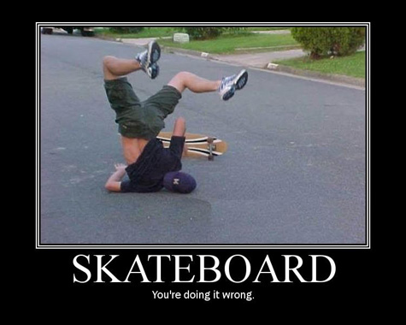

Name: _______________________________

**Homework:**

**Newtons Third Law**

**Action and Reaction**

* Newton’s third law describes something else that happens when ________________________________________________________________________
* According to Newton’s third law of motion, forces always act in ________________________________________________________________________
* It is most commonly phrased as … ________________________________________________________________________

________________________________________________________________________

**Predict**

* Use arrows to show which direction the forces are occurring in the sporting events.

|  |  |
| --- | --- |
| Javelin thrown from hand | Football being kicked by foot |
| Diver leaping off diving board | Basketball about to be dunked |

**Practical**

|  |  |
| --- | --- |
| **Equipment:** | **Activity Options:** |
| Gym  Padding  Sports Equipment | Throw a javelin  Throw a shot put  Run into padding  Hit a ball/kick a ball  Throw a Frisbee   * Regular * Disc   Punch a boxing bag |

**Vectors**

In Physics we use Vectors (arrows) to show the direction of the forces.

The _____________ the arrow the ____________ the force.

The _____________ the arrow the ____________ the force.

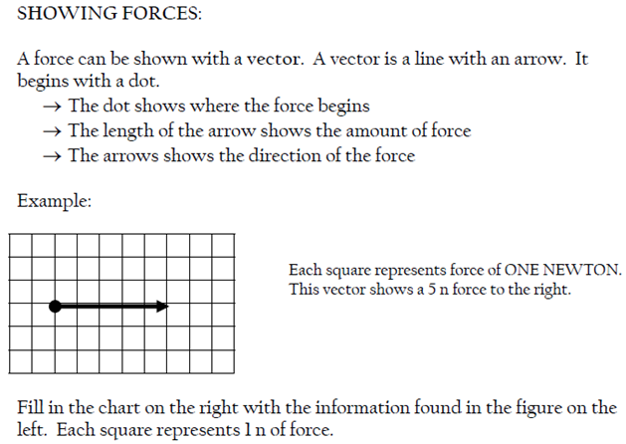



**1**

**2**

**3**

**8**

**9**

**7**

**4**

**10**

**5**

**6**

**Use the vectors above to fill in the table below. The first one is done for you.**

|  |  |  |
| --- | --- | --- |
|  | **Force (N)** | **Direction (North, South, East, West)** |
| **1** | **11 N** | **East** |
| **2** |  |  |
| **3** |  |  |
| **4** |  |  |
| **5** |  |  |
| **6** |  |  |
| **7** |  |  |
| **8** |  |  |
| **9** |  |  |
| **10** |  |  |

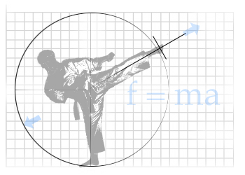

**Action and Reaction Forces Don’t Cancel**

* The forces exerted by two objects on each other are called ____________/______________ force pairs.
* _______________________ can be considered the action force or the reaction force.
* Action and Reaction force pairs ____________________ because they act on different objects
* Label the action and reaction forces appropriately. Action = A, Reaction = R

|  |  |
| --- | --- |
| Javelin thrown from hand | Football being kicked by foot |
| Diver leaping off diving board | Basketball about to be dunked |

**Large and Small Objects**

* Large and Small objects help us to see how these pairs occur.
* If you step on something that has less mass than you do, like a skateboard, what happens to it? ______________________________________
* If you step on something with a lot of mass, like earth, what happens to it? ________________________________________
* Describe how the law of inertia can be explained in this scenario. ________________________________________________________________________________________________________________________________________________________________________________________

**Quick “E”: Balloon Rockets**

* Blow up a balloon. Do not tie the end. Release the balloon and observe its motion.
  + What happens to the balloon in relation to motion? _______________________________________________________________________
  + What is causing that motion? __________________________________________________________________________________________________________________________________________________________________________
  + Draw a diagram showing what is happening to the particles in a balloon and label the action/reaction forces in the diagram.

|  |
| --- |
|  |

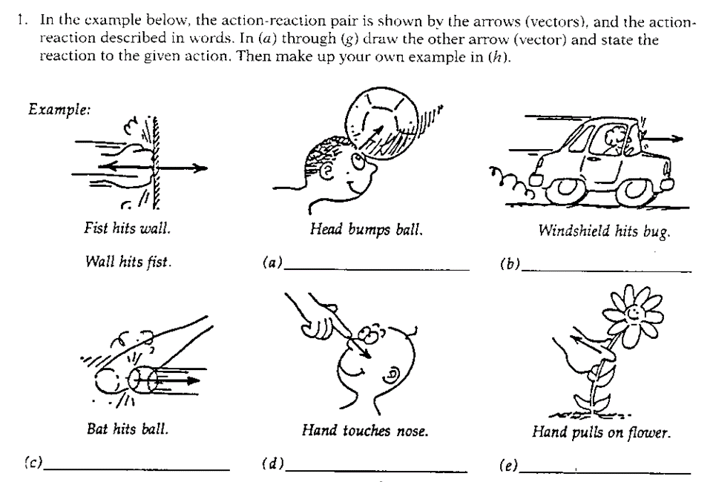**Summary Quiz**

1. Complete the following
2. While driving, Sarah Baker observed a bug striking the windshield of her car. Consider one force to be the bug hitting the windshield.
   1. What is the Newtons’s Third Law pair to this force?
   2. Which of the two forces is greater?

1. Rockets are unable to accelerate in space because. . .
   1. there is no air in space for the rockets to push off of.
   2. there is no gravity in space.
   3. there is no air resistance in space.
   4. nonsense! Rockets do accelerate in space.
2. A gun recoils when it is fired. As the gases from the gunpowder explosion expand, the gun pushes the bullet forwards and the bullet pushes the gun backwards. How do these two forces compare?
   1. The force of the gun on the bullet is larger.
   2. The force of the bullet on the gun is larger.
   3. The forces are the same.
3. The acceleration of the recoiling gun is
   1. greater than the acceleration of the bullet.
   2. smaller than the acceleration of the bullet.
   3. the same size as the acceleration of the bullet.

How do you know?

1. In the top picture, a physics student is pulling upon a rope which is attached to a wall. In the bottom picture, the physics student is pulling upon a rope which is held by the Strongman. In each case, the force scale reads 500 Newtons. The physics student is pulling
   1. with more force when the rope is attached to the wall.
   2. with more force when the rope is attached to the Strongman.
   3. the same force in each case.

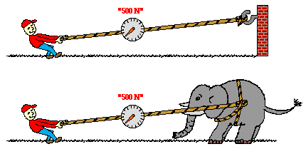

1. A high school student hits a nail with a hammer. During the collision, there is a force
   1. on the hammer but not on the nail.
   2. on the nail but not on the hammer.
   3. on the nail and also on the hammer.
2. A woman weighing 500 N sits on the floor. She exerts a force on the floor of
   1. 5 N.
   2. 50 N.
   3. 250 N.
   4. 500 N.
   5. 1000 N.
3. The floor exerts a force on her of
   1. 5 N.
   2. 50 N.
   3. 250 N.
   4. 500 N.
   5. 1000 N.
4. A person is attracted towards the center of the earth by an 800 N gravitational force. The force with which the earth is attracted toward the person is
   1. very very small.
   2. very very large.
   3. 800 N.
5. An unfortunate bug splatters against your face as you run the 100 meter dash. Compared to the force of your face on the bug, the force of the bug on your face is
   1. larger.
   2. smaller.
   3. the same.
   4. Need more information to say
6. An unfortunate bug splatters against your face as you run the 100 meter dash. Compared to the deceleration of your face, the deceleration of the bug is
   1. larger.
   2. smaller.
   3. the same.

How do you know?

1. A Mack truck and a Volkswagen Bug traveling at the same speed have a head-on collision. The vehicle to undergo the greater change in velocity will be the
   1. Volkswagen.
   2. Mack truck.
   3. Both the same
2. Two people pull on a rope in a tug-of-war. Each pulls with 400 N of force. What is the tension in the rope?
   1. Zero
   2. 400 N
   3. 600 N
   4. 800 N

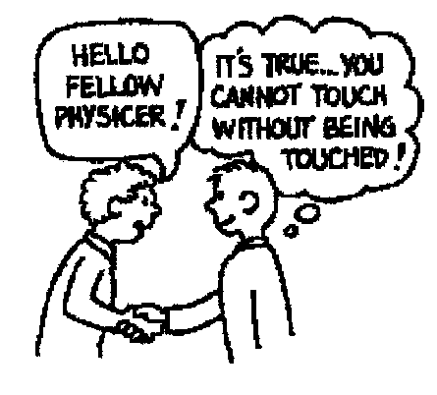**Newton’s Third Law Concept Questions**

1. When a hammer exerts a force on a nail, how does the amount of force compare to that of the nail on the hammer?
2. Why does a cannon recoil when it fires a cannonball?
3. When you jump up, does the world recoil downward? Explain.
4. 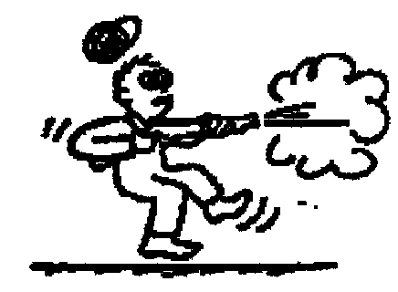Why is it easier to walk on a carpeted floor than on a smooth, polished floor?
5. When a rifle is fired, how does the size of the force of the rifle on the bullet compare to the force of the bullet on the rifle?

- How do the accelerations of the rifle and bullet compare?

1. If a bicycle and a massive truck have a head-on collision, upon which vehicle is the impact force greater?

* Which vehicle undergoes the greater change in acceleration?

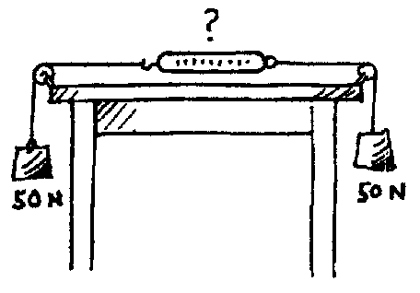

1. A pair of 50 N weights are attached to a spring scale as shown in the diagram. Does the scale read 0, 50, or 100 N?

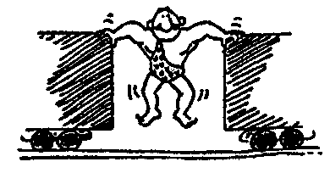

1. The strongman will push the two initially stationary freight cars of equal mass apart before he himself drops to the ground. Is it possible for him to set either of the cars in greater motion than the other? Explain.

1. 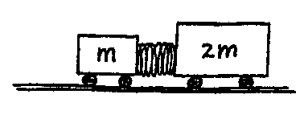Suppose two carts, one twice as massive as the other, fly apart when the compressed spring that joins them is released. Afterwards, how do their speeds compare?

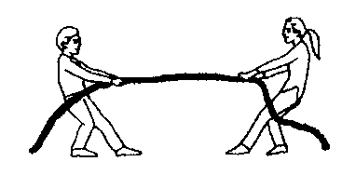

1. Two people of equal mass attempt a tug-of-war with a 12-meter rope while standing on frictionless ice. When they pull on the rope, they each slide toward each other. How far does each person slide before they meet?
2. Suppose in the preceding example that one person has twice the mass of the other. How far does each person slide before they meet?

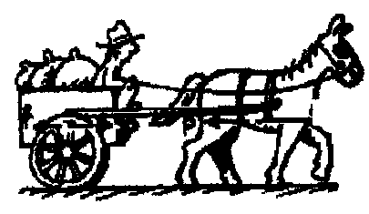

1. A horse pulls a wagon with some force, causing it to accelerate. Newton's third law says that the wagon exerts an equal and opposite reaction force on the horse. How can the wagon move?