Newton’s Second Law of Motion
How fast does it go?

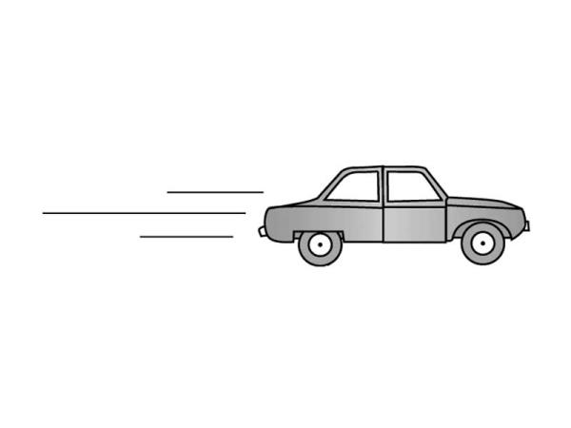

Name: _____________________________________

Homework:

Practical Experiment
- Equipment:
- 1 Plastic Volleyball
- 1 Basketball
- 1 Tennis Balls
- 3 different coloured markers
- Instructions:
- Students will be in groups of 3.
- You will compete to throw each of these further than each other from a set position.
- Each student will be assigned a different coloured marker to mark how far they threw
- You will need to record the distance of ONE of your group members.
- Record the data in meters.
 | Volleyball | Basketball | Tennis Ball
Test 1:

- How do the results show Newton’s Second Law? (We can come back to this later) _________________________________________________________________________________________________________________________________________________________________________________________________________________________________
Remember Newton’s First Law?
- An unbalanced force causes something to __________ (accelerate).
- What was the unbalanced force in your experiment above? ___________________________
Acceleration
- Acceleration is directly related to the _____________________ and the _____________of the force.
- It accelerates in the direction you __________ or ___________ it.

Fill in the missing arrows and labels.
- In other words….
_______________________ = ____________________________________
- And . . .

____________________ = __________________________________________

- So. . . if you push twice as hard, it accelerates _______________________.

- But it depends on the size of the mass.
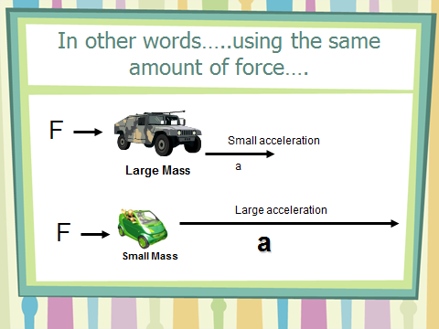
Use the diagram to below to fill in question 12.
- if I use the same amount of force (F) on a . . .

  - large _______ then it will have a ____________ acceleration (a) compared to a
  - ________________ which would have a ___________ acceleration.
Newton’s Second Law
- Newton observed those “rules” of _____________ and came up with his second law of motion.
- It is both ________________ & ___________________.

Newton’s Second Law
- An object will ______________________________________________________________________________________________________________________________________________________
- The size of this acceleration depends upon ______________________________________________________________________________________________________________________________________________________

Newtons Second Law Formula

F_{net} = ma
or
Force = __________ x ___________________
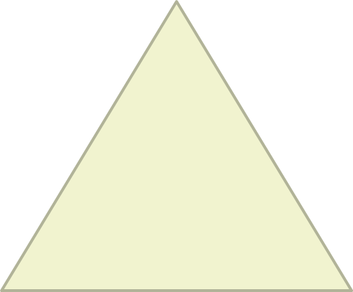

- You need to know the units of Force, Mass & Acceleration.
Name | Units | Symbol
Force
Mass
Acceleration

- Solve these using the formula:
- m = 7kg, a = 2 m/s², therefore F = _____
- m = 500kg, a = 3 m/s², therefore F = _____
- m = 6kg, F = 18 N, therefore a = _____
- F = 25 N, a = 5 m/s², therefore m = _____
Class Demonstration
- 1 Medicine Ball
- 1 Basketball
- Questions:
  - Hypothesis: Which ball will do you think hit the ground first? __________________
  - Give an explanation of why you think that. __________________________________________________________________________________________________________________________________________
  - How close was the time between them hitting the ground? (Circle one)
    - Exactly the same/half a second/one second/three seconds
  - Was your hypothesis correct? ___________
  - Why or why not? _______________________________________________________________________________________________________________________________________________________________________________________________________________
End of Second Law
Practice Calculations

- Rearrange the following equation to solve for mass and acceleration.

F_{net} = ma

- Practice Newton’s Second Law calculations by completing the following table;

Force | Mass | Acceleration
56 N |  | 6 m/s²
108 N |  | 2.5 m/s²
 | 3.4 kg | 12 m/s²
 | 120 kg | 1.4 m/s²
10 N |  | 2.0 m/s²
118 N |  | 6.8 m/s²
5.5 N | 15,000 kg
1.2 N | 3,500 kg
 | 8.2 kg | 1.2 m/s²
 | 196 kg | 38 m/s²

Newton’s Second Law - Concept Questions

- If the forces exerted on a 2-kg object are 50 N east and 30 N west, what is object’s acceleration?

- Suppose a cart is being pushed by a certain net force. If the net force is doubled, by how much does the acceleration change?

- Suppose a cart is being moved by a certain net force. If a box is dumped into the cart, so its mass is doubled, by how much does the acceleration change?

- If a loaded truck can accelerate at four m/s² and loses its load so it is only half as massive, what acceleration can it attain for the same driving force?

- A rocket fired from its launching pad not only picks up speed, but also has a significant increase in its acceleration as firing continues. Why is this so?

- Harry the painter swings year after year from his boson’s chair. His weight is 500 N and rope unknown to him, has a breaking point of 300 N.

- Why doesn't the rope break when he is supported as shown in the first figure to the right?

- One day, Harry is painting near a flagpole, and for a change, he ties the free end of the rope to the flagpole instead of to his chair. What happens to Harry?

- The force of gravity is twice as great on a 2-kg rock as on a 1-kg rock. Why then does the 2-kg rock not fall with twice the acceleration?
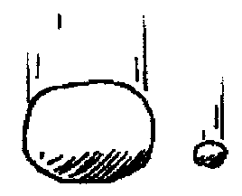

- If you pulled a low but heavy crate with a rope and greased the bottom to reduce friction, would it help more to use a short rope or a long rope?

Extension Questions

- What is the net force acting on a 10 kg freely falling object?

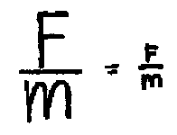
- What is the net force when it encounters 15 N of air resistance?

- How much air resistance does it experience when it falls at terminal velocity?

- An elevator (mass = 1000 kg) is supported by a single cable.

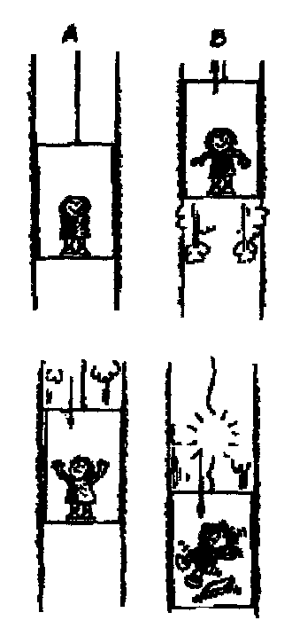
- When the elevator is at rest, what is the tension in the cable?

- The elevator starts to move upwards at 1m/s/s. Is the scale reading more, less, or the same?

- When the elevator is ascending upward at a constant speed, is the tension more, less, or the same as (a)?

- The elevator begins to slow as it reaches the proper floor. Is the tension more, less, or the same as (a)?

- The elevator now starts to descend at an increasing speed. Is the tension more, less, or the same as (a)?

- If the cable snapped and the elevator fell freely, what would be the tension?

