**Year 10 Science**

**Types of Chemical Reactions**

**Revision Booklet 2017**

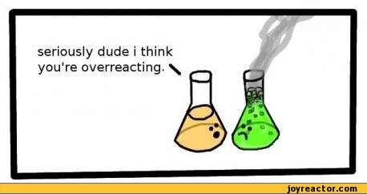

Can you?

Standard/Intermediate

* Balance a chemical equation
* Identify decomposition and synthesis reactions
* Predict acid reactions (acid + metal hydroxide, acid + metal oxide, acid + carbonate)
* Predict metal reactions - reactive metal + acid, using activity series… metal + water/steam/oxygen, displacement reactions)
* Explain Hydrocarbon combustion
* Predict precipitation reactions
* Describe factors affecting rates of reaction

**Name: __________________________________**

**Teachers Name: ____________________________________**

**Balancing Chemical Equations**

1. Complete the following table. Name what atoms are present and how many there are of each.

|  |  |
| --- | --- |
| **K3PO4** |  |
| **H2CO3** |  |
| **2CO2** |  |
| **2Fe(OH)3** |  |
| **3Ca3(PO4)2** |  |

1. Balance the following by adding coefficients.

____P4 + ____O2 🡪 ____P2O3

____N2 + ____H2 🡪 ____NH3

____K + ____Cl2 🡪 ____KCl

____N2 + ____F2 🡪 ____NF3

1. Attempt to balance the following:

____ Pb(OH)2 + ____ HCl 🡪 ____ H20 + ____ PbCl2

**Identify decomposition and synthesis reactions (Oxford 4.1)**

Decomposition Reactions

In decomposition reactions, one compound will break down into two or more parts, according to the general pattern: AB 🡪 A + B

Write the formula equation for the following decomposition reactions.

1. barium carbonate → barium oxide + carbon dioxide

1. magnesium carbonate → magnesium oxide + carbon dioxide

1. potassium carbonate → potassium oxide + carbon dioxide

1. zinc hydroxide → zinc oxide + water

1. iron(II) hydroxide → iron(II) oxide + water

1. nickel(II) chlorate → nickel(II) chloride + oxygen

1. sodium chlorate → sodium chloride + oxygen

1. potassium chlorate → potassium chloride + oxygen

1. sulfuric acid → water + sulfur trioxide

1. carbonic acid → water + carbon dioxide

1. aluminium oxide → aluminium + oxygen

1. silver oxide → silver + oxygen

Synthesis Reactions

In synthesis reactions, two or more reactants come together to form one compound, following the general pattern:

A + B 🡪 AB

Write the formula equation for the following synthesis reactions.

1. calcium + oxygen → calcium oxide

1. copper + sulfur → copper(II) sulfide

1. calcium oxide + water → calcium hydroxide

1. hydrogen + nitrogen → ammonia

1. hydrogen + chlorine → hydrogen chloride

1. silver + sulfur → silver sulfide

1. chromium + oxygen → chromium(III) oxide

1. aluminium + bromine → aluminium bromide

1. sodium + iodine → sodium iodide

1. hydrogen + oxygen → water

1. aluminium + oxygen → aluminium oxide

Synthesis and Decomposition Reactions

For each reaction below, (i) identify it as either a synthesis (S) or decomposition (D) reaction, (ii) write each chemical formula to complete the equation in full.

1. potassium + oxygen → potassium oxide
2. calcium + oxygen → calcium oxide
3. barium carbonate → barium oxide + carbon dioxide
4. lithium + sulfur → lithium sulfide
5. magnesium chlorate → magnesium chloride + oxygen
6. strontium + nitrogen → strontium nitride
7. potassium + bromine → potassium bromide
8. sodium chlorate → sodium chloride + oxygen
9. hydrogen + iodine → hydrogen iodide
10. calcium chloride → calcium + chlorine

**Answers Decomposition**

1. barium carbonate → barium oxide + carbon dioxide

BaCO3 → BaO + CO2

1. magnesium carbonate → magnesium oxide + carbon dioxide

MgCO3 → MgO + CO2

1. potassium carbonate → potassium oxide + carbon dioxide

K2CO3 → K2O + CO2

1. zinc hydroxide → zinc oxide + water

Zn(OH)2 → ZnO + H2O

1. iron(II) hydroxide → iron(II) oxide + water

Fe(OH)2 → FeO + H2O

1. nickel(II) chlorate → nickel(II) chloride + oxygen

Ni(ClO3)2 → NiCl2 + 3O2

1. sodium chlorate → sodium chloride + oxygen

2NaClO3 → 2NaCl + 3O2

1. potassium chlorate → potassium chloride + oxygen

2KClO3 → 2KCl + 3O2

1. sulfuric acid → water + sulfur trioxide

H2SO4 → H2O + SO3

1. carbonic acid → water + carbon dioxide

H2CO3 → H2O + CO2

1. aluminium oxide → aluminium + oxygen

2Al2O3 → 4Al + 3O2

1. silver oxide → silver + oxygen

2Ag2O → 4Ag + O2

**Answers Synthesis**

1. calcium + oxygen → calcium oxide

2Ca + O2 → 2CaO

1. copper + sulfur → copper(II) sulfide

8Cu + S8  → 8CuS

1. calcium oxide + water → calcium hydroxide

CaO + H2O → Ca(OH)2

1. hydrogen + nitrogen → ammonia

3H2 + N2 → 2NH3

1. hydrogen + chlorine → hydrogen chloride

H2 + Cl2 → 2HCl

1. silver + sulfur → silver sulfide

16Ag + S8 → 8Ag2S

1. chromium + oxygen → chromium(III) oxide

4Cr + 3O2 → 2Cr2O3

1. aluminium + bromine → aluminium bromide

2Al + 3Br2 → 2AlBr3

1. sodium + iodine → sodium iodide

2Na + I2 → 2NaI

1. hydrogen + oxygen → water

2H2 + O2 → 2H2O

1. aluminium + oxygen → aluminium oxide

4Al + 3O2 → 2Al2O3

**Acid reactions acid + metal hydroxide, acid + metal oxide, acid + carbonate (Oxford 4.2)**

**Acid reactions**

**Acids** almost always have a ‘**H**’ at the front of their formula (it is this that forms H+ ions)

Some common ones you should know are: Hydrochloric acid (HCl), Nitric acid (HNO3) and sulphuric acid (H2SO4)

**Bases** almost always have ‘**O’ or ‘OH’** at the end of their formula (they react with water to form OH- ions).

Some common ones you should know are: Sodium Hydroxide (NaOH), Ammonia (NH3 –an exception to our rule) and iron oxide (Fe2O3)

**Carbonates** always have ‘**CO3**’ at the end of their formula (it is this that makes CO2 when it reacts with acid)

Some common ones are: Calcium carbonate (CaCO3), sodium Carbonate (Na2CO3) and Sodium Hydrogencarbonate (NaHCO3)

1. **Identify the formula below as acid, metal, base or carbonate:**
2. 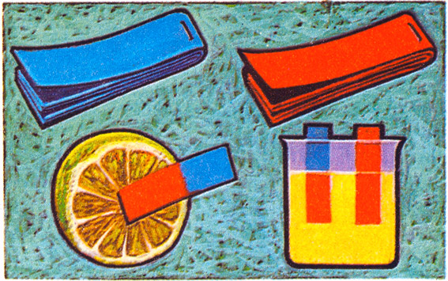HsSO4 _________________________
3. ZnCO3 __________________________
4. NaOH ___________________________
5. Zn(OH)2 ____________________________
6. HCl _____________________________
7. CUO _______________________________
8. Mg _________________________________
9. H3PO4 _______________________________
10. Ca _________________________________
11. Zn(HCO3)2 _______________________________
12. Fe2O3 _________________________________
13. Al __________________________________
14. Ba(OH)2 ________________________________
15. Aluminium hydroxide ____________________________
16. Carbonic acid _______________________________
17. Potassium oxide ________________________________
18. Magnesium Carbonate ______________________________
19. Sodium Hydroxide _______________________________

**There are three types of acid reactions you need to know:**

1. **Acid + metal 🡪 salt + hydrogen gas**
2. **Acid + base 🡪 salt + water**
3. **Acid + carbonate 🡪 salt + water + carbon dioxide**
4. **Identify these as one of these types of reactions (e.g. acid + base) and write the products (e.g. salt + water):**
5. 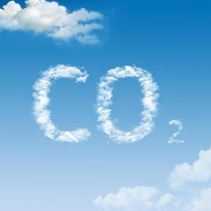Sodium Hydroxide + Hydrochloric acid
6. Sulfuric acid + zinc
7. Sulfuric acid + calcium
8. Nitric acid + Sodium hydrogencarbonate
9. Nitric acid + iron oxide

When writing molecular formula equations, you will need to commit these things to memory: Water (**H2O**), Carbon dioxide (**CO2**) and hydrogen gas **(H2).**

To write the full equation, you:

1. Swap and drop to get any formula you don’t know e.g. Ba2+CO32- becomes BaCO3
2. Write out the reactants and draw in the arrow (e.g. BaCO3 + HCl 🡪 )
3. Identify the type of reaction (e.g. acid + carbonate)
4. Write the products you already know (e.g. BaCO3 + HCl 🡪H2O + CO2 )
5. Ignore any letters in the reactants that have been used to make products (e.g. ignore H, O and C because they have been used to make H2O and CO2 : BaCO3 + HCl)
6. Use what is left to write your salt formula by swapping and dropping (e.g. Ba2+Cl- becomes BaCl2)
7. Balance the equation
8. You have the finished product! (E.g. BaCO3 + 2HCl 🡪H2O + CO2 + BaCl2)
9. Complete the equations on the next page using this information.
10. 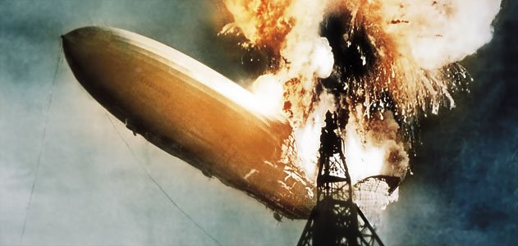**Complete these equations**
11. ZnCO3 + HCl 🡪
12. Zn + HCl 🡪
13. Mg + H2SO4 🡪
14. CuO + HNO3 🡪
15. MgCO3 + H3PO4 🡪
16. Cu(OH)2 + HCl 🡪
17. Iron (II) metal and Hydrochloric acid 🡪
18. Zinc hydroxide + Hydrochloric acid 🡪
19. Aluminium Carbonate + Hydrochloric acid 🡪

**Acid reactions worksheet 2**

1. **From memory try to Identify the following as acid, base, metal or carbonate:**

HCl ____________________

Ca____________________

HF____________________

RbOH____________________

Fe2(CO3)3____________________

Ca(OH)2____________________

HNO3____________________

Pb____________________

H2SO4____________________

KOH____________________

Au____________________

CaCO3____________________

HC2H3O2____________________

Fe____________________

Cu2CO3____________________

Cr2(CO3)3____________________

H3PO4____________________

Al2(CO3)3____________________

C3H6O____________________

NH3____________________

Sn(CO3)2____________________

LiOH____________________

Al(OH)3____________________

Sn____________________

K2CO3____________________

1. **For each equation:**
2. Write the general formula (e.g. acid + base 🡪 salt + water)
3. Write the formula for the products (except the salt)
4. Cross out the parts of the reactants used to form the reactants you already have, and write the remaining ones as a salt (using swap and drop) or, consider that the metal takes the place of the hydrogen in the acid

Al(OH)3 + HCl

K2CO3 + H2SO4

Ca + H2SO4

LiOH + HCl

RbOH + HNO3

CaCO3 + HNO3

HF + RbOH

KOH + HCl

**Metal reactions (reactive metal + acid, using activity series… metal + water/steam/oxygen, displacement reactions)**



*For the following reactions, (1) complete the word equation; (2) complete and balance the chemical equation provided.*

1. Reactive Metal + Acid 🡪 ________ + _________

__Mg(s) +__ HCl(aq) 🡪 ________ + _________

1. [K, Na, Ca] + Water/Steam 🡪 ________ + _________

__Ca(s) + __H2O(l) 🡪 ________ + _________

1. [Mg, Al, Zn, Fe, Ni, Sn, Pb] + Steam 🡪 ________ + _________

__Al(s) + __H2O(g) 🡪 ________ + _________

1. [Cu, Hg, Ag, Pt, Au] + Water/Steam 🡪 _________________

__Ca(s) + __H2O(g) 🡪 ________ + _________

1. Metal + Oxygen gas 🡪 _________________

__Zn(s) + __O2(g) 🡪 ____________

1. Using the Activity Series of Metals, fill in the table below, to ***show what solid will form*** (if any) if the metals are put in solutions of tin chloride and copper iodide. If you think nothing will happen, write “no reaction”.

|  |  |  |
| --- | --- | --- |
| **METALS**: | **in tin chloride solution** | **in copper iodide solution** |
| Aluminium |  |  |
| Tin |  |  |
| Silver |  |  |

1. Write balanced equations for the following reactions. [6 marks]

|  |
| --- |
| Sodium + cold water  _________ + ________ ________ + _________ |
| zinc + dilute sulfuric acid  _________ + _________ ________ + ________ |
| Aluminium + superheated steam  _________ + _________ ________ + ________ |

**Precipitation reactions (Oxford 4.3)**

* + **Refer to your booklet on Types of Reactions**

**Predicting Precipitation Reactions**

Predict whether a precipitation reaction will take place between two aqueous solutions of ionic compounds, and if the answer is yes, to write the complete equation for the reaction.

Ex. Li2CO­3(aq) + Al(NO3)3(aq) 🡪 ?

Precipitation (double replacement) reactions follow the general equation:

**AB + CD → AD + CB**

STEP 1: Write the formulas for the products AD and CB

*Caution*: Don’t forget to check the charges and criss-cross if necessary!

Ex: Li2CO­3(aq) + Al(NO3)3(aq) 🡪 LiNO3 + Al2(CO3)3

STEP 2: Use the SOLUBILITY RULES TABLE to determine whether either of the possible products is **insoluble**. If either possible product is insoluble, a precipitation reaction takes place, and continue to Step 3. If neither is insoluble, write “no reaction”

Ex. LiNO3 = soluble (all nitrates soluble)

Al2(CO­3)3 = insoluble (carbonates insoluble; aluminum not an exception)

STEP 3: Put an (s) for solid next to the **insoluble** product. This is the precipitate formed in the reaction. It does not dissolve. Put (aq) next to the compound that is water-soluble.

Ex: Li2CO­3(aq) + Al(NO3)3(aq) 🡪 LiNO3**(aq)** + Al2(CO3)3**(s)**

STEP 4: Balance the equation. *Mission accomplished*.

Ex: 3 Li2CO­3(aq) + 2 Al(NO3)3(aq) 🡪 6 LiNO3(aq) + Al2(CO3)3(s)

**Practice**:

1. KOH(aq) + Fe(NO3)3(aq) →
2. K2SO4(aq) + Pb(NO3)2(aq) →
3. CaCl2(aq) + Na3PO4(aq) →
4. KNO3(aq) + MgI2(aq) →

**Hydrocarbon combustion (Oxford 4.4)**

* + **Refer to Booklet on Types of Reactions**

**Factors affecting reaction rate (Oxford 4.6)**

* + **Refer to your booklet on “Rates of Reactions”**

