Swan Christian College

Year 10 Science
Some examination revision

Chemical Science

- When an atom loses an electron:
a a positive ion is formed
b a negative ion is formed
c the atomic number is changed
d the mass number is changed
Explain your answer
________________________________________________________________
________________________________________________________________
________________________________________________________________

- The elements sodium, lithium, potassium and caesium all form ions with a charge of:
a 1+
b 2+
c 3+
d 1+ and 2+
To what group of the periodic table do these elements belong? Explain why they form ions of this charge?
________________________________________________________________
________________________________________________________________
________________________________________________________________

- An unknown substance (X) was found to combine with chlorine to form an ionic compound of XCl₃. How many valence electrons does element X have?
A 1
b 2
c 3
d 4
What are valence electrons?

- Hypothetical element X, which has 2 electrons in its outermost shell, is reacted with element Y, which has 7 valence electrons. Which of the following statements is INCORRECT?

A The ions formed are X²⁺ and Y–.
b The compound has the formula XY₂.
C Element X donates electrons to element Y.
d The compound formed is covalent.
Explain why the statement is incorrect.

- Complete the table below, which shows the structure of a number of atoms. Use your periodic table as required.

Name of element |  | Atomic number | Mass number | Number of protons | Number of neutrons | Number of electrons | Electron configuration
Neon |  |  | 21 |  |  |  | 2 8
 |  |  | 31 |  | 16
 | $${}_{19}^{39}K$$ |  |  |  |  | 19

- Name the following compounds:
  - CuS _______________________________
  - Al(OH)₃ _________________________
  - NaF _______________________________
  - SO₃ _______________________________

- Write the formula of the following substances:
- Magnesium iodide _____________________
- Silver nitrate _____________________
- Carbon tetrachloride _____________________
- Iron ___________________________

- A student draws the diagram below to represent the electron configuration of a neutral atom.

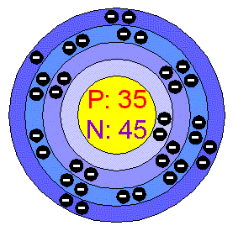

a What is the name of the element?

b Write the electron configuration for the element

c To what group of the periodic table does the element belong? Explain how you made your decision.

d If this atom was to form an ion what would be its charge? Why?

________________________________________________________

The next two questions are based on the following table, which summarizes the properties of four different substances numbered I, II, III and IV.
Substance | Melting Point (ºC) | Electrical Conductivity in Solids | Electrical Conductivity in Molten State | Hardness and Malleability
I | -7 | Non-Conductor | Non-  Conductor | Soft
II | 1083 | Good Conductor | Good Conductor | Hard and Malleable
III | 801 | Non-Conductor | Conducts electricity | Hard and brittle
IV | 3550 | Non-Conductor | Non-Conductor | Hard and brittle

- Which substance would be classified as ionic?

a) I b) II
c) III d) IV

- Which substance would be classified as a covalent network solid?

a) I b) II
c) III d) IV

- Give the name of the following, and state the type of bonding (metallic, covalent network, covalent molecular or ionic) that is present.

SUBSTANCE | NAME | BONDING TYPE
Ca
SiO₂
CaO
NH₃
NH₄Cl

- Give the electron configuration for –
Carbon _____________________
Argon ______________________
Sodium _____________________
Oxide ion ___________________

- Draw electron dot diagrams for the following –
- oxygen gas (O₂)

b. magnesium chloride (MgCl₂)

c. carbon tetrachloride (CCl₄)

- carbon dioxide (CO₂)

Complete the following table by giving the correct chemical formula for the named molecules.
Barium phosphate |  | Sodium oxide
Potassium sulfide |  | Silver sulfate
Ammonium carbonate |  | Magnesium nitrate
Tin II hydroxide |  | Zinc phosphate
Sodium sulfide |  | Potassium sulfate
Silver carbonate |  | Ammonium hydrogen carbonate
Sodium fluoride |  | Tin IV chloride
Silver bromide |  | Ammonium iodide
Magnesium sulfate |  | Calcium carbonate
Zinc hydrogen carbonate |  | Barium hydrogen sulfate
Iron II nitrate |  | Cobalt hydroxide
Potassium bromide |  | Silver iodide
Magnesium carbonate |  | Calcium hydrogen carbonate
Zinc hydrogen sulfate |  | Barium nitrate
Copper II phosphate |  | Iron III hydroxide
Sodium bromide |  | Potassium iodide
Silver oxide |  | Ammonium sulfide
Calcium hydrogen sulfate |  | Zinc nitrate
Sodium hydroxide |  | Iron II phosphate
Sodium sulfite |  | Potassium oxide
Silver sulfide |  | Ammonium sulfate
Calcium nitrate |  | Zinc hydroxide
Sodium ethanoate |  | Potassium permanganate
Iron III hydrogen carbonate |  | Copper I fluoride
Aluminium sulfide |  | Manganese bromide
Iron III oxide |  | Lead II sulfate

- Complete the following table that gives the name of some common acids and their formulas. The first has been done for you.

Name of acid | Formula
Hydrochloric acid | HCl
Sulfuric acid
 | HNO₃
Phosphoric acid
Carbonic acid
 | CH₃COOH

- Complete these general word equations for chemical reactions:

Acid + Reactive Metal → ____________ + ____________
Acid + Metal Oxide → ____________ + ____________
Acid + Metal Hydroxide → ____________ + ____________
Acid + Carbonate → ____________ + ____________ + ____________
Acid + Hydrogencarbonate → ____________ + ____________ + ____________
Acid + Base → ____________ + ____________
Metal + Oxygen → ____________
Non-metal + Oxygen → ____________
[K, Na, or Ca] + water → ____________ + ____________
[Al, Zn, Fe, Ni, Sn, or Pb] + steam → ____________ + ____________
[Cu, Hg, Ag, Pt, or Au] + water/steam → ____________

- Identify the following substances by choosing a name from the box. Write the correct name next to the substance.
Metal hydroxide Non-metal oxide Metal Oxide
Metal carbonate Metal hydrogencarbonate Metal ion
Metal Salt

Al₂O₃ ___________________

Ni ___________________

Fe(OH)₃ ___________________

Zn(CO₃) ___________________

SO₃ ______________________

KHCO₃ ____________________

CaCl₂ ______________________

Mg²⁺_______________________

- Convert the following word equations to symbol form and then balance them. Write your balanced equation underneath the word equation

- calcium + water calcium hydroxide + hydrogen gas
_________ + _________ ________ + ________

- zinc metal + nitric acid zinc nitrate + hydrogen gas
_________ + _________ ________ + ________

- lead + silver ions lead II ions + silver
________ + _________ ________ + ________

- Write the word equations below as chemical equations and balance:

  - Zinc and lead (II) nitrate react to form zinc nitrate and lead.

  - Aluminum bromide and chlorine gas react to form aluminum chloride and bromine gas.

  - Sodium phosphate and calcium chloride react to form calcium phosphate and sodium chloride.

  - Potassium metal and chlorine gas combine to form potassium chloride.

  - Aluminum and hydrochloric acid react to form aluminum chloride and hydrogen gas.

  - Calcium hydroxide and phosphoric acid react to form calcium phosphate and water.

  - Copper and sulfuric acid react to form copper (II) sulfate and water and sulfur dioxide.

  - Hydrogen gas and nitrogen monoxide react to form water and nitrogen gas.

- Using the Activity Series of Metals, fill in the table below, to show what solid will form (if any) if the metals are put in solutions of tin chloride and copper iodide. If you think nothing will happen, write “no reaction”.

METALS: | in tin chloride solution | in copper iodide solution
Aluminium
Tin
Silver

- Write balanced equations for the following reactions. [6 marks]

Sodium + cold water
_________ + ________ ________ + _________
zinc + dilute sulfuric acid
_________ + _________ ________ + ________

Aluminium + superheated steam
_________ + _________ ________ + ________

- Balance the equations below:

- ____ CH₄ + ____ O₂ ____ CO₂ + ____ H₂O

- ____ C₃H₈ + ____ O₂ ____ CO₂ + ____ H₂O

- ____ FeCl₃ + ____ NaOH ____ Fe(OH)₃ + ____NaCl

- ____ Na + ____ H₂O ____ NaOH + ____H₂

- ____ Ag₂O ____ Ag + ____O₂

- ____ CO₂ + ____ H₂O ____ C₆H₁₂O₆ + ____O₂

- ____ K + ____ MgBr₂ ____ KBr + ____ Mg

- ____ H₂O + ____ O₂ ____ H₂O₂

- ____ NaBr + ____ CaF₂ ____ NaF + ____ CaBr₂

- ____ H₂SO₄ + ____ NaNO₂ ____ HNO₂ + ____ Na₂SO₄

- Main reactions involving acidic substances
For the following reactions, (1) complete the word equation; (2) complete and balance the chemical equation provided.

- Acid + Metal Hydroxide ________ + _________
__H₂SO_{4(aq)} +__ Fe(OH)_{2(aq)} ________+ _________

- Non-Metal Oxide + Metal Hydroxide ________ + _________
__CO_{2(g)} + __Ba(OH)_{2(aq)} ________ + _________

- Acid + Metal Oxide ________ + _________
__HNO_{3(aq)} + __Al₂O_{3(s)} ________ + _________

- Acid + Metal Carbonate ________ + _________ + _________
__HCl_{(aq)} + __CaCO_{3(s)} ________ + _________ + _________

- Acid + Hydrogencarbonate ________ + _________ + _________
__H₂SO_{4(aq)} + __KHCO_{3(aq)} ________ + _________ + ________

- Write the NET IONIC equations below as chemical equations and balance:
  - Aluminum and hydrochloric acid react to form aluminum chloride and hydrogen gas.

  - Calcium hydroxide and phosphoric acid react to form calcium phosphate and water.

  - Copper and sulfuric acid react to form copper (II) sulfate and water and sulfur dioxide.

  - Hydrogen gas and nitrogen monoxide react to form water and nitrogen gas.

- The solutions below are mixed. For each of the mixtures, predict whether or not a chemical reaction will occur. Where a reaction occurs, indicate both the molecular equation and net ionic equation. If a reaction does not occur, write ‘no reaction’.
a silver nitrate and potassium chloride

Molecular equation:

Net ionic equation:

b sulphuric acid and Sodium metal

Molecular equation:

Net ionic equation:

c sodium nitrate and potassium chloride

Molecular equation:

Net ionic equation:

Reactions producing precipitates
- Use the solubility rules to determine if the following ionic solids are soluble in water.
- CuCO₃
- MgCl₂
- Zn(OH)₂
- Ca₃(PO₄)₂

- Write ionic equations for each of the following precipitate forming reactions. If no precipitate forms, write ‘No Reaction’.
- __NiCl_{2(aq)} + __Na₂S_{(aq)}

- __Al₂(SO₄)_{3(aq)} + __Ba(OH)_{2(aq)}
Displacement Reactions
- A student was given a shiny grey metal and asked to identify what element it is composed of. The metal was placed in different solutions to see if it would react. It was found that it reacted with copper(II) sulfate solution but not with zinc nitrate solution.
- Which metal (or metals) could the rod be made of?

- What other test could be done to determine the identity of the metal?

Data and Tables
Activity Series
K
Na
Ca
Al
Zn
Fe
Ni
Sn
Pb
Cu
Hg
Ag
Pt
Au

Biology
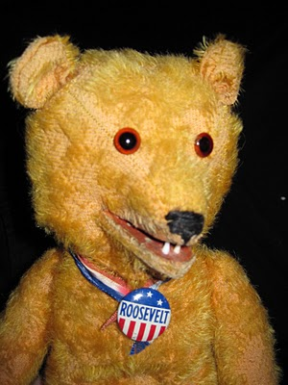
1. Observe the following population of teddy bears.

2. Will natural selection be able to act on this population? Why or why not?
_________________________________________________________________________________________________________________________________________________________________________________________________________________________________

3. After several millions of years, the following mutant arose in the teddy bear population.
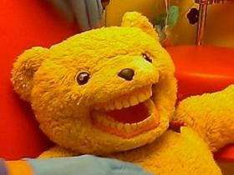
This mutant found it could eat more food types than the normal type teddy. For example, it could chew up vegetables and hard biscuits whereas the normal type teddy was stuck eating soft foods like cake and marshmallows. However, the mutant was also much more susceptible to tooth decay and cavities.
4. In what type of situation would the mutant teddy be at a disadvantage, resulting in it’s genes not being passed on, and it’s type dying out?
_________________________________________________________________________________________________________________________________________________________________________________________________________
5. Describe a situation where the mutant type teddy would be at an advantage. Name the selective pressure in this situation.
_________________________________________________________________________________________________________________________________________________________________________________________________________

6. The environmental factor that causes a change in a population is said to be imposing
a) artificial selection
b) selection pressure
c) sexual selection
d) evolution

7. Explain what sexual selection is.
____________________________________________________________________________________________________________________________________________________________________________________________________________________________________________________________________________

8. How might sexual selection help the survival of a species?
_________________________________________________________________________________________________________________________________________________________________________________________________________

9. Name some types of variation that can be found in a cat population.
_________________________________________________________________________________________________________________________________________________________________________________________________________

10. Give the genetic definition of natural selection
_________________________________________________________________________________________________________________________________________________________________________________________________________

11. The following diagram illustrates a theory of evolution that was proposed before Darwin proposed his theory.

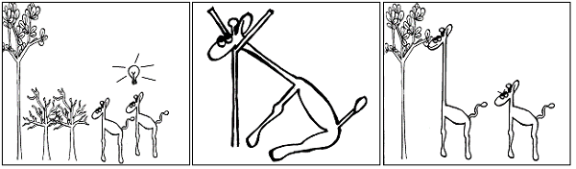
DIES!

Eg. Giraffes stretch their necks in order to reach the higher trees. When the smaller trees dies out, the giraffe with the longer (stretched) neck survives, and passes the long neck onto its’ offspring.
Explain what is wrong with this theory, in light of our current understanding of genetics.
_______________________________________________________________________________________________________________________________________________________________________________________________________________________________________________________________________________________________________________________________________________

12. In the example of the peppered moths;

a) What moth types existed before the tree colours changed?
___________________________________________________________________
b) What moth types existed after the tree colours changed?
___________________________________________________________________
c) Was any new genetic information added to the moth population?
___________________________________________________________________
d) What actually did change in the moth population?
___________________________________________________________________
e) If there had only been light coloured moths in the population, what would have happened to the moth population?
______________________________________________________________________________________________________________________________________

13. a) What was the pesticide resistance in some insects due to?
______________________________________________________________________________________________________________________________________
b) What happens every time the farmer sprays with the same pesticide?
______________________________________________________________________________________________________________________________________

c) What is the selective agent in this case?_________________________________

d) This is an example of
i) artificial selection
ii) natural selection
iii) sexual selection
iv) environmental pressure

14. The name for the genetic makeup of an organism is _______________________
The name for the characteristics of an organism is it’s ________________________

15. a) Is it correct to say that bacteria ‘become’ resistant to antibiotics?__________
If not, why not? _______________________________________________________
______________________________________________________________________________________________________________________________________

b) How do bacteria reproduce, and how fast does this occur?
_________________________________________________________________________________________________________________________________________________________________________________________________________

c) What will you need to do if you are infected with bacteria that are resistant to the antibiotic you are using?
_________________________________________________________________________________________________________________________________________________________________________________________________________

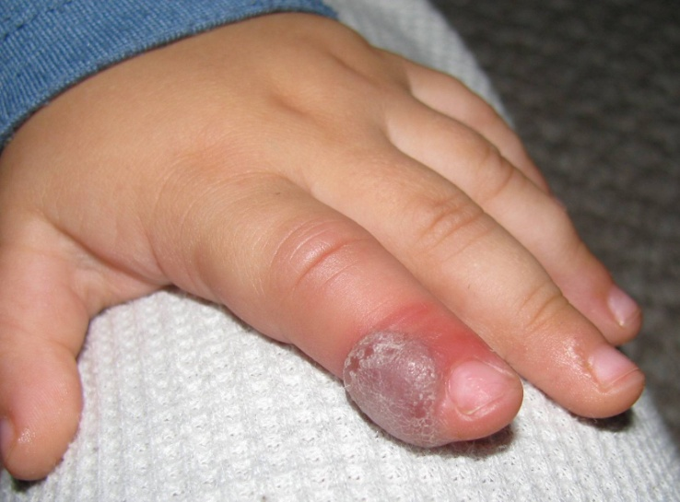
d) How is antibiotic resistance beneficial to the bacteria?
_________________________________________________________________________________________________________________________________________________________________________________________________________

e) If a population of bacteria becomes resistant to an antibiotic (over several generations), can you say evolution has occurred? Why or why not?
_________________________________________________________________________________________________________________________________________________________________________________________________________

16.
a) What are the two main sources of genetic variation?
______________________________________________________________________________________________________________________________________

b) Prior to the use of antibiotics, humans still had some defence against bacterial infection. What was/is it? _______________________________________________

c) Name some factors that have contributed to the increase in the number of antibiotic resistant bacteria
____________________________________________________________________________________________________________________________________________________________________________________________________________________________________________________________________________

d) Name an alternative to antibiotics that has been used to greatly reduce the incidence of bacterial infection. _________________________________________

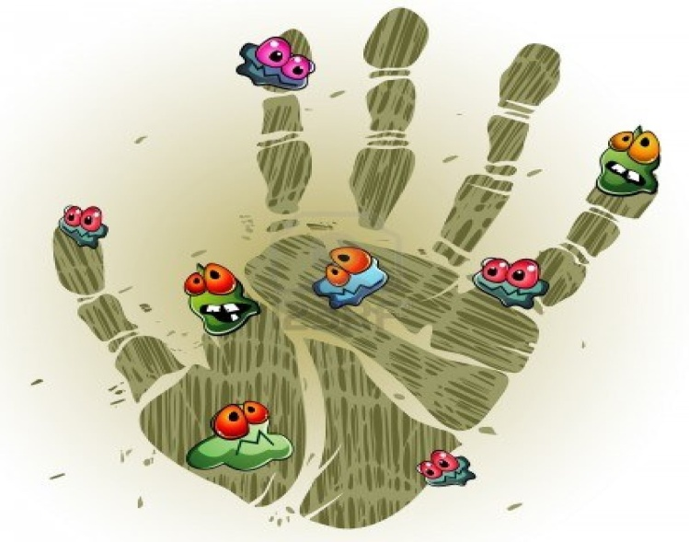
e) How could bacteria that have never been exposed to antibiotics, contain antibiotic resistant genes? ______________________________________________________
_____________________________________________________________________________________________

